## PROGRAM DEFINITION

|  |
| --- |
|  |
| * Program transaksi untuk semua kebutuhan CARE |

## RELATED TABLES

|  |  |
| --- | --- |
|  | **Access** |
| * HDT_TRANS_HD * HDT_TRANS_SUPERVISOR * HDT_TRANS_STAFF * HDT_TRANS_CHECKLIST * HDT_TRANS_CHARGES * HDT_TRANS_IMAGES * HDM_SYSTEM_PARAM * HDM_ASSET * HDM_PUBLIC_LOCATION * HDM_TASK * HDM_TASK_CHECKLIST | * RW * RW * RW * RW * RW * RW * R * R * R * R * R |

## ROLES

|  |  |
| --- | --- |
|  | **Test** |
| * User yg mempunyai akses ke program |  |

## INITIAL PROCESS

|  |  |
| --- | --- |
|  | **Test** |
| * Set VAR_COMPANY_ID = Login User’s Company ID * Set VAR_USER_ID = Login User ID * Set VAR_LANGUAGE_ID = Login User’s Language ID * **Get Property List**   Jalankan RSP_GS_GET_PROPERTY_LIST dengan parameter, simpan hasil ke VAR_SELECTED_PROPERTY   * + VAR_COMPANY_ID   + VAR_LANGUAGE_ID * **Get HD System Parameter**   Jalankan RSP_HD_GET_SYSTEM_PARAM dengan parameter, simpan hasil ke VAR_HD_SYSTEM_PARAM   * + VAR_COMPANY_ID   + VAR_SELECTED_PROPERTY.CPROPERTY_ID * **Get CARE Category**   Jalankan RSP_GS_GET_GSB_CODE_LIST dengan parameter, simpan hasil ke VAR_CARE_CATEGORY   * + ‘BIMASAKTI’   + VAR_COMPANY_ID   + ‘_BS_CARE_CATEGORY’   + VAR_LANG_ID * Set VAR_FILTERED_CARE_CATEGORY = Filter VAR_CARE_CATEGORY where CCODE = ‘01’ and CCODE = ‘02’ * **Get Priority**   Jalankan RSP_GS_GET_GSB_CODE_LIST dengan parameter, simpan hasil ke VAR_PRIORITY   * + ‘BIMASAKTI’   + VAR_COMPANY_ID   + ‘_BS_CRITICAL_LEVEL’   + VAR_LANG_ID * **Get Area**   Jalankan RSP_GS_GET_GSB_CODE_LIST dengan parameter, simpan hasil ke VAR_AREA   * + ‘BIMASAKTI’   + VAR_COMPANY_ID   + ‘_BS_AREA’   + VAR_LANG_ID * **Get Caller Category**   Jalankan RSP_GS_GET_GSB_CODE_LIST dengan parameter, simpan hasil ke VAR_CALLER_CATEGORY   * + ‘BIMASAKTI’   + VAR_COMPANY_ID   + ‘_BS_CALLER_CATEGORY’   + VAR_LANG_ID * **Get Caller Registration**   Jalankan RSP_GS_GET_GSB_CODE_LIST dengan parameter, simpan hasil ke VAR_CALLER_REGISTRATION   * + ‘BIMASAKTI’   + VAR_COMPANY_ID   + ‘_BS_CALLER_REGISTRATION’   + VAR_LANG_ID * **Get Assignment Type**   Jalankan RSP_GS_GET_GSB_CODE_LIST dengan parameter, simpan hasil ke VAR_ASSIGNMENT_TYPE   * + ‘BIMASAKTI’   + VAR_COMPANY_ID   + ‘_BS_ASSIGNMENT_TYPE’   + VAR_LANG_ID |  |

## TAB CARE PROCESS

### USER INTERFACE

#### [CR01]

#### 

#### INITIAL VERSION

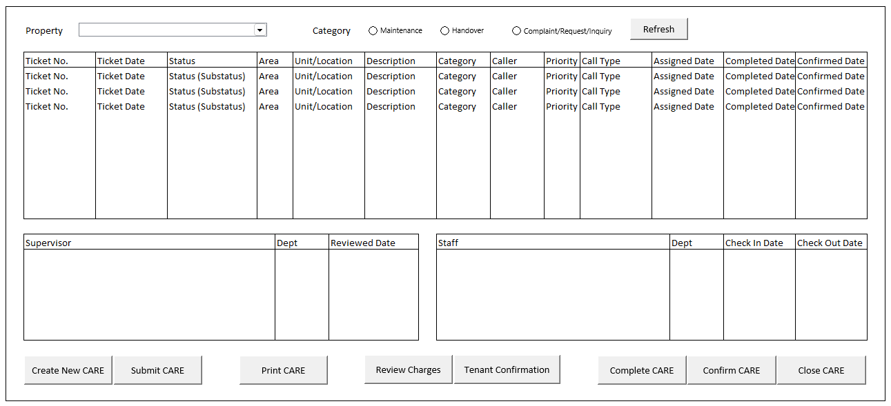

### BUTTON DEFINITION

|  |  |  |
| --- | --- | --- |
| **Button Name** | **Action** | **Enabled** |
| Refresh | Jalankan REFRESH PROCESS |  |
| Create New CARE | Jalankan CREATE NEW CARE PROCESS | * VAR_SELECTED_CATEGORY = “O” |
| Submit CARE | Jalankan SUBMIT CARE PROCESS | * VAR_SELECTED_CARE.LENABLE_SUBMIT = TRUE |
| Print CARE | Jalankan PRINT CARE PROCESS | * VAR_SELECTED_CARE.LENABLE_PRINT = TRUE |
| Review Charges | Jalankan REVIEW CHARGES PROCESS | * VAR_SELECTED_CARE.LENABLE_REVIEW_CHARGES = TRUE |
| Tenant Confirmation | Jalankan TENANT CONFIRMATION PROCESS | * VAR_SELECTED_CARE.LENABLE_CONFIRM_CHARGES = TRUE |
| Complete CARE | Jalankan COMPLETE CARE PROCESS | * VAR_SELECTED_CARE.LENABLE_COMPLETE = TRUE |
| Confirm CARE | Jalankan CONFIRM CARE PROCESS | * VAR_SELECTED_CARE.LENABLE_CONFIRM = TRUE |
| Close CARE | Jalankan CLOSE CARE PROCESS | * VAR_SELECTED_CARE.LENABLE_CLOSE = TRUE |

### ROLES

|  |  |
| --- | --- |
|  | **Test** |
| * User yg punya akses ke program |  |

### INITIAL PROCESS

|  |  |
| --- | --- |
|  | **Test** |
| * Set VAR_CATEGORY (as array of object) with VAR_CODE and VAR_NAME.   + Set VAR_CODE = ‘M’, ‘H’, ‘O’   + Set VAR_NAME = Maintenance, Handover, Complaint/Request/Inquiry * Set VAR_SELECTED_CATEGORY = ‘O’ * **Load CARE List**   Jalankan RSP_HD_GET_CARE_LIST dengan parameter, simpan hasil ke VAR_CARE_LIST dan VAR_SELECTED_CARE   * + VAR_COMPANY_ID   + VAR_SELECTED_PROPERTY.CPROPERTY_ID   + VAR_SELECTED_CATEGORY   + VAR_LANG_ID * **Load CARE Detail**   Jalankan RSP_HD_GET_CARE_DETAIL dengan parameter, simpan hasil ke VAR_SELECTED_CARE   * + VAR_COMPANY_ID   + VAR_SELECTED_PROPERTY.CPROPERTY_ID   + VAR_SELECTED_CARE.CCARE_TICKET_NO   + VAR_LANG_ID * **Load Supervisor List**   Jalankan RSP_HD_GET_CARE_SUPERVISOR_LIST dengan parameter, simpan hasil ke VAR_SUPERVISOR_LIST dan VAR_SELECTED_SUPERVISOR   * + VAR_COMPANY_ID   + VAR_SELECTED_PROPERTY.CPROPERTY_ID   + VAR_SELECTED_CARE.CCARE_TICKET_NO   + VAR_LANG_ID   + 1 * **Load Staff List**   Jalankan RSP_HD_GET_CARE_STAFF_LIST dengan parameter, simpan hasil ke VAR_STAFF_LIST dan VAR_SELECTED_STAFF   * + VAR_COMPANY_ID   + VAR_SELECTED_PROPERTY.CPROPERTY_ID   + VAR_SELECTED_CARE.CCARE_TICKET_NO   + VAR_SELECTED_SUPERVISOR.CSUPERVISOR_ID   + VAR_LANG_ID |  |

### DISPLAY PROCESS

#### FIELD DEFINITION

|  |  |  |  |
| --- | --- | --- | --- |
| **Name** | **Field** | **Type** | **Validation** |
| Property | CPROPERTY_ID | Combobox  Isi combobox dengan RSP_GS_GET_PROPERTY_LIST dengan parameter   * VAR_COMPANY_ID * VAR_USER_ID   Set ValueField = CPROPERTY_ID  Set TextField = CPROPERTY_NAME  Simpan hasil ke VAR_SELECTED_PROPERTY | On Value Changed,  **Load CARE List** Jalankan RSP_HD_GET_CARE_LIST dengan parameter, simpan hasil ke VAR_CARE_LIST dan VAR_SELECTED_CARE:   * + VAR_COMPANY_ID   + VAR_SELECTED_PROPERTY.CPROPERTY_ID   + VAR_SELECTED_CATEGORY   + VAR_LANG_ID   **Load CARE Detail** Jalankan RSP_HD_GET_CARE_DETAIL dengan parameter, simpan hasil ke **VAR_SELECTED_CARE**:   * + VAR_COMPANY_ID   + VAR_SELECTED_PROPERTY.CPROPERTY_ID   + VAR_SELECTED_CARE.CCARE_TICKET_NO   + VAR_LANG_ID   **Load Supervisor List** Jalankan RSP_HD_GET_CARE_SUPERVISOR_LIST dengan parameter, simpan hasil ke VAR_SUPERVISOR_LIST dan VAR_SELECTED_SUPERVISOR:   * + VAR_COMPANY_ID   + VAR_SELECTED_PROPERTY.CPROPERTY_ID   + VAR_SELECTED_CARE.CCARE_TICKET_NO   + VAR_LANG_ID   **Load Staff List** Jalankan RSP_HD_GET_CARE_STAFF_LIST dengan parameter, simpan hasil ke VAR_STAFF_LIST dan VAR_SELECTED_STAFF:   * + VAR_COMPANY_ID   + VAR_SELECTED_PROPERTY.CPROPERTY_ID   + VAR_SELECTED_CARE.CCARE_TICKET_NO   + VAR_SELECTED_SUPERVISOR.CSUPERVISOR_ID   + VAR_LANG_ID |
| Category | VAR_SELECTED_CATEGORY | RadioButton  Isi radiobutton dengan VAR_CATEGORY  Set ValueField = VAR_CODE  Set TextField = VAR_NAME  Simpan hasil ke VAR_SELECTED_CATEGORY | On Selected Changed,  **Load CARE List** Jalankan RSP_HD_GET_CARE_LIST dengan parameter, simpan hasil ke VAR_CARE_LIST dan VAR_SELECTED_CARE:   * + VAR_COMPANY_ID   + VAR_SELECTED_PROPERTY.CPROPERTY_ID   + VAR_SELECTED_CATEGORY   + VAR_LANG_ID   **Load CARE Detail** Jalankan RSP_HD_GET_CARE_DETAIL dengan parameter, simpan hasil ke **VAR_SELECTED_CARE**:   * + VAR_COMPANY_ID   + VAR_SELECTED_PROPERTY.CPROPERTY_ID   + VAR_SELECTED_CARE.CCARE_TICKET_NO   + VAR_LANG_ID   **Load Supervisor List** Jalankan RSP_HD_GET_CARE_SUPERVISOR_LIST dengan parameter, simpan hasil ke VAR_SUPERVISOR_LIST dan VAR_SELECTED_SUPERVISOR:   * + VAR_COMPANY_ID   + VAR_SELECTED_PROPERTY.CPROPERTY_ID   + VAR_SELECTED_CARE.CCARE_TICKET_NO   + VAR_LANG_ID   **Load Staff List** Jalankan RSP_HD_GET_CARE_STAFF_LIST dengan parameter, simpan hasil ke VAR_STAFF_LIST dan VAR_SELECTED_STAFF:   * + VAR_COMPANY_ID   + VAR_SELECTED_PROPERTY.CPROPERTY_ID   + VAR_SELECTED_CARE.CCARE_TICKET_NO   + VAR_SELECTED_SUPERVISOR.CSUPERVISOR_ID   + VAR_LANG_ID |
| **CARE Grid** |  | **Data:** VAR_CARE_LIST  **Type**: Navigator | Allow: -  View Only  On Selected Changed,  Set **VAR_SELECTED_CARE** = Selected Row’s Data  **Load CARE Detail** Jalankan RSP_HD_GET_CARE_DETAIL dengan parameter, simpan hasil ke **VAR_SELECTED_CARE**:   * + VAR_COMPANY_ID   + VAR_SELECTED_PROPERTY.CPROPERTY_ID   + VAR_SELECTED_CARE.CCARE_TICKET_NO   + VAR_LANG_ID   **Load Supervisor List** Jalankan RSP_HD_GET_CARE_SUPERVISOR_LIST dengan parameter, simpan hasil ke VAR_SUPERVISOR_LIST dan VAR_SELECTED_SUPERVISOR:   * + VAR_COMPANY_ID   + VAR_SELECTED_PROPERTY.CPROPERTY_ID   + VAR_SELECTED_CARE.CCARE_TICKET_NO   + VAR_LANG_ID   **Load Staff List** Jalankan RSP_HD_GET_CARE_STAFF_LIST dengan parameter, simpan hasil ke VAR_STAFF_LIST dan VAR_SELECTED_STAFF:   * + VAR_COMPANY_ID   + VAR_SELECTED_PROPERTY.CPROPERTY_ID   + VAR_SELECTED_CARE.CCARE_TICKET_NO   + VAR_SELECTED_SUPERVISOR.CSUPERVISOR_ID   + VAR_LANG_ID |
| Ticket No. | CCARE_TICKET_NO | Textbox, Disabled |  |
| Ticket Date. | DCARE_TICKET_DATE | DateTimePicker, Disabled |  |
| Status | CSTATUS_DESCRIPTION, CSUBSTATUS_DESCRIPTION  Set Display:  CSTATUS_DESCRIPTION (CSUBSTATUS_DESCRIPTION) | Textbox, Disabled |  |
| Area | CAREA_DESCRIPTION | Textbox, Disabled |  |
| Building  **[CR01]** | CBUILDING_ID | Textbox, Disabled |  |
| Unit/Location | CUNIT_LOCATION_ID | Textbox, Disabled |  |
| Description | CCARE_DESCRIPTION | Textbox, Disabled |  |
| ~~Category~~  **[CR01]** | ~~CCALLER_CATEGORY_DESCRIPTION, CCALLER_SUBCATEGORY~~  ~~Set Display:~~  ~~IF CCALLER_SUBCATEGORY is not EMPTY, then~~  ~~CCALLER_CATEGORY_DESCRIPTION (CCALLER_SUBCATEGORY)~~  ~~Else,~~  ~~CCALLER_CATEGORY_DESCRIPTION~~ | ~~Textbox, Disabled~~ |  |
| Caller | CCALLER_NAME | Textbox, Disabled | **Notes: Grid must show at least until this column** |
| Category  **[CR01]** | CCALLER_CATEGORY_DESCRIPTION, CCALLER_SUBCATEGORY  Set Display:  IF CCALLER_SUBCATEGORY is not EMPTY, then  CCALLER_CATEGORY_DESCRIPTION (CCALLER_SUBCATEGORY)  Else,  CCALLER_CATEGORY_DESCRIPTION | Textbox, Disabled |  |
| Priority | CPRIORITY_DESCRIPTION | Textbox, Disabled |  |
| Call Type | CCALL_TYPE_ID | Textbox, Disabled |  |
| Assigned Date | DASSIGNED_DATE | DateTimePicker, Disabled |  |
| Completed Date | DCOMPLETED_DATE | DateTimePicker, Disabled |  |
| Confirmed Date | DCONFIRMED_DATE | DateTimePicker, Disabled |  |
| **Supervisor Grid** |  | **Data:** VAR_SUPERVISOR_LIST  **Type**: Original | Allow: -  ViewOnly  On Selected Changed,  Set **VAR_SELECTED_SUPERVISOR** = Selected Row’s Data  **Load Staff List** Jalankan RSP_HD_GET_CARE_STAFF_LIST dengan parameter, simpan hasil ke VAR_STAFF_LIST dan VAR_SELECTED_STAFF:   * + VAR_COMPANY_ID   + VAR_SELECTED_PROPERTY.CPROPERTY_ID   + VAR_SELECTED_CARE.CCARE_TICKET_NO   + VAR_SELECTED_SUPERVISOR.CSUPERVISOR_ID   + VAR_LANG_ID |
| Supervisor | CSUPERVISOR_ID, CSUPERVISOR_NAME  Set Display:  CSUPERVISOR_ID – CSUPERVISOR_NAME | Textbox, Disabled |  |
| Dept | CSUPERVISOR_DEPT_CODE | Textbox, Disabled |  |
| Reviewed Date | DSUPERVISOR_REVIEWED_DATE | DateTimePicker, Disabled |  |
| **Staff Grid** |  | **Data**: VAR_STAFF_LIST  Type: Original | Allow: -  ViewOnly  On Selected Changed,  Set **VAR_SELECTED_STAFF** = Selected Row’s Data |
| Staff | CSTAFF_ID, CSTAFF_NAME  Set Display:  CSTAFF_ID – CSTAFF_NAME | Textbox, Disabled |  |
| Dept | CSTAFF_DEPT_CODE | Textbox, Disabled |  |
| Check In Date | DSTAFF_CHECK_IN_DATE | DateTimePicker, Disabled |  |
| Check Out Date | DSTAFF_CHECK_OUT_DATE | DateTimePicker, Disabled |  |

### REFRESH PROCESS

|  |
| --- |
|  |
| * **Load CARE List**   Jalankan RSP_HD_GET_CARE_LIST dengan parameter, simpan hasil ke VAR_CARE_LIST dan VAR_SELECTED_CARE   * + VAR_COMPANY_ID   + VAR_SELECTED_PROPERTY.CPROPERTY_ID   + VAR_SELECTED_CATEGORY   + VAR_LANG_ID * **Load CARE Detail**   Jalankan RSP_HD_GET_CARE_DETAIL dengan parameter, simpan hasil ke VAR_SELECTED_CARE   * + VAR_COMPANY_ID   + VAR_SELECTED_PROPERTY.CPROPERTY_ID   + VAR_SELECTED_CARE.CCARE_TICKET_NO   + VAR_LANG_ID * **Load Supervisor List**   Jalankan RSP_HD_GET_CARE_SUPERVISOR_LIST dengan parameter, simpan hasil ke VAR_SUPERVISOR_LIST dan VAR_SELECTED_SUPERVISOR   * + VAR_COMPANY_ID   + VAR_SELECTED_PROPERTY.CPROPERTY_ID   + VAR_SELECTED_CARE.CCARE_TICKET_NO   + VAR_LANG_ID * **Load Staff List**   Jalankan RSP_HD_GET_CARE_STAFF_LIST dengan parameter, simpan hasil ke VAR_STAFF_LIST dan VAR_SELECTED_STAFF   * + VAR_COMPANY_ID   + VAR_SELECTED_PROPERTY.CPROPERTY_ID   + VAR_SELECTED_CARE.CCARE_TICKET_NO   + VAR_SELECTED_SUPERVISOR.CSUPERVISOR_ID   + VAR_LANG_ID |

### CREATE NEW CARE PROCESS (DETAIL TAB)

#### USER INTERFACE

##### INITIAL VERSION

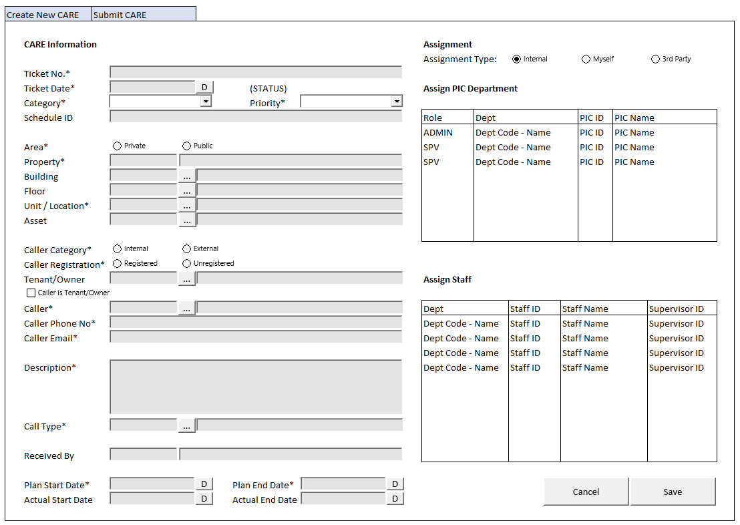

#### BUTTON DEFINITION

|  |  |  |
| --- | --- | --- |
| **Button Name** | **Action** | **Enabled** |
| Cancel | Jalankan CANCEL PROCESS |  |
| Save | Jalankan PROCESS |  |

#### INPUT PARAMETER

|  |  |
| --- | --- |
| **Parameter Name** | **Description** |
| PARAM_SELECTED_PROPERTY | VAR_SELECTED_PROPERTY from TAB CARE PROCESS |

#### ROLES

|  |  |
| --- | --- |
|  | **Test** |
| * User yg punya akses ke program |  |

#### INITIAL PROCESS

|  |  |
| --- | --- |
|  | **Test** |
| * Load data from Input Parameter * Set FORM_DATA = new CARE_DTO object * Set VAR_ASSIGNED_SUPERVISOR_LIST = Empty List * Set VAR_ASSIGNED_STAFF_LIST = Empty List * Set VAR_ROLE (as array of object) with VAR_CODE and VAR_NAME.   + Set VAR_CODE = ‘A’, ‘S’   + Set VAR_NAME = Admin, Supervisor |  |

#### DISPLAY PROCESS

##### FIELD DEFINITION

|  |  |  |  |
| --- | --- | --- | --- |
| **Name** | **Field** | **Type** | **Validation** |
| **Display Form** |  | **Data**: FORM_DATA |  |
| **CARE Information** |  |  |  |
| Ticket No. | CCARE_TICKET_NO | Textbox, Disabled, Required |  |
| Ticket Date | DCARE_TICKET_DATE | DateTimePicker, Required | Set Default = NOW |
| (STATUS) | CSTATUS, CSUBSTATUS  Set Display:  IF CSTATUS = ‘04’, then  ~~CSTATUS_DESCRIPTION~~ ~~(CSUBSTATUS_DESCRIPTION)~~  CSUBSTATUS_DESCRIPTION **[CR01]**  Else  CSTATUS_DESCRIPTION | Label, **BOLD** |  |
| Category | CCARE_CATEGORY | Combobox, Required  Isi combobox dengan **VAR_FILTERED_CARE_CATEGORY**  Set ValueField = CCODE  Set TextField = CNAME  Simpan hasil ke CCARE_CATEGORY | Set Default = ‘03’ |
| Priority | CPRIORITY | Combobox, Required  Isi combobox dengan **VAR_PRIORITY**  Set ValueField = CCODE  Set TextField = CNAME  Simpan hasil ke CPRIORITY | Set Default = ‘02’ |
| Schedule ID | CSCHEDULE_ID | Textbox, Disabled | Hidden on,  CCARE_CATEGORY <> ‘01’ |
| Area | CAREA | Radiobutton, Required  Isi radiobutton dengan **VAR_AREA**  Set ValueField = CCODE  Set TextField = CNAME  Simpan hasil ke CAREA | Set Default = ‘01’ |
| Property | Set CPROPERTY_ID = PARAM_SELECTED_PROPERTY. CPROPERTY_ID | Textbox, Disabled, Required |  |
|  | Set CPROPERTY_NAME = PARAM_SELECTED_PROPERTY. CPROPERTY_NAME | Textbox, Disabled |  |
| Building | CBUILDING_ID | Textbox, Disabled | Enabled on  CAREA = ‘01’  On Lost Focus,  Go to 🡪 BUILDING LOOKUP PROCESS  On Lookup Process Successful, update:  CBUILDING_ID, CBUILDING_NAME |
|  |  | Lookup, Disabled | Enabled on  CAREA = ‘01’  On Lookup Button Clicked,  Go to 🡪 BUILDING LOOKUP PROCESS  On Lookup Process Successful, update:  CBUILDING_ID, CBUILDING_NAME |
|  | CBUILDING_NAME | Textbox, Disabled |  |
| Floor | CFLOOR_ID | Textbox, Disabled | Enabled on  CAREA = ‘01’  On Lost Focus,  IF CBUILDING_ID = ‘’  Show Message “Please choose building first!”  Else, Go to 🡪 FLOOR LOOKUP PROCESS  On Lookup Process Successful, update:  CFLOOR_ID, CFLOOR_NAME |
|  |  | Lookup, Disabled | Enabled on  CAREA = ‘01’  On Lookup Button Clicked,  IF CBUILDING_ID = ‘’  Show Message “Please choose building first!”  Else, Go to 🡪 FLOOR LOOKUP PROCESS  On Lookup Process Successful, update:  CFLOOR_ID, CFLOOR_NAME |
|  | CFLOOR_NAME | Textbox, Disabled |  |
| Unit/Location | CUNIT_LOCATION_ID | Textbox, Required | **IF CAREA = ‘01’**  On Lost Focus,  IF CBUILDING_ID = ‘’  Show Message “Please choose building first!”  IF CFLOOR_ID = ‘’  Show Message “Please choose floor first!”  Else, Go to 🡪 UNIT LOOKUP PROCESS  On Lookup Process Successful, update:  CUNIT_LOCATION_ID, CUNIT_LOCATION_NAME  **IF CAREA = ‘02’**  On Lost Focus,  Go to 🡪 LOCATION LOOKUP PROCESS  On Lookup Process Successful, update:  CUNIT_LOCATION_ID, CUNIT_LOCATION_NAME,  CBUILDING_ID, CBUILDING_NAME, CFLOOR_ID, CFLOOR_NAME |
|  |  | Lookup | **IF CAREA = ‘01’**  On Lookup Button Clicked,  Go to 🡪 UNIT LOOKUP PROCESS  On Lookup Process Successful, update:  CUNIT_LOCATION_ID, CUNIT_LOCATION_NAME  **IF CAREA = ‘02’**  On Lookup Button Clicked,  Go to 🡪 LOCATION LOOKUP PROCESS  On Lookup Process Successful, update:  CUNIT_LOCATION_ID, CUNIT_LOCATION_NAME,  CBUILDING_ID, CBUILDING_NAME, CFLOOR_ID, CFLOOR_NAME |
|  | CUNIT_LOCATION_NAME | Textbox, Disabled |  |
| Asset | CASSET_ID | Textbox | On Lost Focus,  Go to 🡪 ASSET LOOKUP PROCESS  On Lookup Process Successful, update:  CASSET_ID, CASSET_NAME, CBUILDING_ID, CBUILDING_NAME, CFLOOR_ID, CFLOOR_NAME, CUNIT_LOCATION_ID, CUNIT_LOCATION_NAME |
|  |  | Lookup | On Lookup Button Clicked,  Go to 🡪 ASSET LOOKUP PROCESS  On Lookup Process Successful, update:  CASSET_ID, CASSET_NAME, CBUILDING_ID, CBUILDING_NAME, CFLOOR_ID, CFLOOR_NAME, CUNIT_LOCATION_ID, CUNIT_LOCATION_NAME |
|  | CASSET_NAME | Textbox, Disabled |  |
| Caller Category | CCALLER_CATEGORY | Radiobutton, Required  Isi radiobutton dengan **VAR_CALLER_CATEGORY**  Set ValueField = CCODE  Set TextField = CNAME  Simpan hasil ke CCALLER_CATEGORY | Set Default = ‘02’  On Value Changed,  IF CCALLER_CATEGORY changed to ‘01’, then  CCALLER_REGISTRATION = ‘01’  Set Caller Registration disabled  IF CCALLER_CATEGORY changed to ‘02’, then  CCALLER_REGISTRATION = ‘01’  Set Caller Registration enabled |
| Caller Registration | CCALLER_REGISTRATION | Radiobutton, Disabled, Required  Isi radiobutton dengan **VAR_CALLER_REGISTRAION**  Set ValueField = CCODE  Set TextField = CNAME  Simpan hasil ke CCALLER_REGISTRATION | Enabled on,  CCALLER_CATEGORY = ‘02’  Set Default = ‘01’ |
| Tenant/Owner | CTENANT_OWNER_ID | Textbox, Disabled | Enabled on,  CCALLER_CATEGORY = ‘02’  **IF CAREA = ‘01’**  On Lost Focus,  Go to 🡪 UNIT TENANT LOOKUP PROCESS  **IF CAREA = ‘02’**  On Lost Focus,  Go to 🡪 TENANT LOOKUP PROCESS  On Lookup Process Successful, update:  CTENANT_OWNER_ID, CTENANT_OWNER_NAME, CTENANT_ONWER_PHONE, CTENANT_OWNER_EMAIL, CTENANT_OR_OWNER |
|  |  | Lookup | Enabled on,  CCALLER_CATEGORY = ‘02’  **IF CAREA = ‘01’**  On Lookup Button Clicked,  Go to 🡪 UNIT TENANT LOOKUP PROCESS  **IF CAREA = ‘02’**  On Lookup Button Clicked,  Go to 🡪 TENANT LOOKUP PROCESS  On Lookup Process Successful, update:  CTENANT_OWNER_ID, CTENANT_OWNER_NAME, CTENANT_ONWER_PHONE, CTENANT_OWNER_EMAIL, CTENANT_OR_OWNER |
|  | CTENANT_OWNER_NAME | Textbox, Disabled |  |
|  | CTENANT_OWNER_PHONE | Hidden |  |
|  | CTENANT_OWNER_EMAIL | Hidden |  |
|  | CTENANT_OR_OWNER | Hidden |  |
| Caller is Tenant/Owner | LCALLER_IS_TENANT | Checkbox, Disabled, Required | Set Default = FALSE  Enabled on,  CCALLER_CATEGORY = ‘02’  On Disabled,  Set LCALLER_IS_TENANT = FALSE  On Value Changed,  IF LCALLER_IS_TENANT changed to TRUE, then  Set CCALLER_ID = CTENANT_OWNER_ID  Set CCALLER_NAME = CTENANT_OWNER_ID  Set CCALLER_PHONE = CTENANT_OWNER_PHONE  Set CCALLER_EMAIL = CTENANT_ONWER_EMAIL  IF LCALLER_IS_TENANT changed to FALSE, then  Set CCALLER_ID, CCALLER_NAME, CCALLER_PHONE, CCALLER_EMAIL to “” |
| Caller | CCALLER_ID | Textbox, Disabled, Required | Enabled On,  LCALLER_IS_TENANT = FALSE  CCALLER_REGISTRATION = ‘01’  **IF CCALLER_CATEGORY = ‘01’**  On Lost Focus,  Go to 🡪 STAFF LOOKUP PROCESS  **IF CCALLER_CATEGORY = ‘02’ & CAREA = ‘01’**  On Lost Focus,  IF CBUILDING_ID = ‘’  Show Message “Please choose building first!”  IF CFLOOR_ID = ‘’  Show Message “Please choose floor first!”  IF CUNIT_ID = ‘’  Show Message “Please choose unit first!”  Else, Go to 🡪 UNIT TENANT LOOKUP PROCESS  **IF CCALLER_CATEGORY = ‘02’ & CAREA = ‘02’**  On Lost Focus,  Go to 🡪 TENANT LOOKUP PROCESS  On Lookup Process Successful, update:  CCALLER_ID, CCALLER_NAME, CCALLER_PHONE, CCALLER_EMAIL |
|  |  | Lookup, Disabled | Enabled On,  LCALLER_IS_TENANT = FALSE  CCALLER_REGISTRATION = ‘01’  **IF CCALLER_CATEGORY = ‘01’**  On Lookup Button Clicked,  Go to 🡪 STAFF LOOKUP PROCESS  **IF CCALLER_CATEGORY = ‘02’ & CAREA = ‘01’**  On Lookup Button Clicked,  IF CBUILDING_ID = ‘’  Show Message “Please choose building first!”  IF CFLOOR_ID = ‘’  Show Message “Please choose floor first!”  IF CUNIT_ID = ‘’  Show Message “Please choose unit first!”  Else, Go to 🡪 UNIT TENANT LOOKUP PROCESS  **IF CCALLER_CATEGORY = ‘02’ & CAREA = ‘02’**  On Lookup Button Clicked,  Go to 🡪 TENANT LOOKUP PROCESS  On Lookup Process Successful, update:  CCALLER_ID, CCALLER_NAME, CCALLER_PHONE, CCALLER_EMAIL |
|  | CCALLER_NAME | Textbox, Disabled, Required | Enabled On,  LCALLER_IS_TENANT = FALSE  CCALLER_REGISTRATION = ‘02’ |
| Caller Phone No | CCALLER_PHONE | Textbox, Required |  |
| Caller Email | CCALLER_EMAIL | Textbox, Required |  |
| Description | CCARE_DESCRIPTION | Textarea, Required | Max Length = 1000 |
| Call Type | CCALL_TYPE_ID | Textbox, Required | On Lost Focus,  Go to 🡪 CALL TYPE LOOKUP PROCESS  On Lookup Process Successful, update:  CCALL_TYPE_ID, CCALL_TYPE_NAME, CCALL_TYPE_DAYS, CCALL_TYPE_HOURS, CCALL_TYPE_MINUTES |
|  |  | Lookup | On Lookup Button Clicked,  Go to 🡪 CALL TYPE LOOKUP PROCESS  On Lookup Process Successful, update:  CCALL_TYPE_ID, CCALL_TYPE_NAME, CCALL_TYPE_DAYS, CCALL_TYPE_HOURS, CCALL_TYPE_MINUTES |
|  | CCALL_TYPE_NAME | Textbox, Disabled |  |
| Call Type Days | CCALL_TYPE_DAYS | Hidden |  |
| Call Type Hours | CCALL_TYPE_HOURS | Hidden |  |
| Call Type Minutes | CCALL_TYPE_MINUTES | Hidden |  |
| Submitted By | CRECEIVED_BY | Textbox, Disabled |  |
|  | DRECEIVED_DATE | DateTimePicker, Disabled |  |
| Plan Start Date | DPLAN_START_DATE | DateTimePicker, Required | On Value Changed,  Set DPLAN_END_DATE =  DPLAN_START_DATE’s days + CCALL_TYPE_DAYS,  DPLAN_START_DATE’s hours + CCALL_TYPE_HOURS,  DPLAN_START_DATE’s minutes + CCALL_TYPE_MINUTES  Ex.  DPLAN_START_DATE = 1 January 2025, 19:30  CCALL_TYPE_DAYS = 1  CCALL_TYPE_HOURS = 6  CCALL_TYPE_MINUTES = 30  Then,  DPLAN_END_DATE = 3 January 2025, 02:00 |
| Plan End Date | DPLAN_END_DATE | DateTimePicker, Disabled |  |
| Actual Start Date | DACTUAL_START_DATE | DateTimePicker, Disabled |  |
| Actual End Date | DACTUAL_END_DATE | DateTimePicker, Disabled |  |
| **Assignment** |  |  |  |
| Assignment Type | CASSIGNMENT_TYPE | Radiobutton, Required  Isi radiobutton dengan **VAR_ASSIGNMENT_TYPE**  Set ValueField = CCODE  Set TextField = CNAME  Simpan hasil ke CASSIGNMENT_TYPE | Set Default = ‘01’  On Value Changed,  IF CASSIGNMENT_TYPE changed to ‘01’, then  Set **Assign Supervisor Grid** Enabled  Set **Assign Staff Grid** Enabled  IF CASSIGNMENT_TYPE changed to ’02’ or ‘03’, then  Set **Assign Supervisor Grid** Disabled  Set **Assign Staff Grid** Disabled  Set VAR_ASSIGNED_SUPERVISOR_LIST = ‘’  Set VAR_ASSIGNED_STAFF_LIST = ‘’ |

##### GRID DEFINITION

|  |  |  |  |
| --- | --- | --- | --- |
| **Name** | **Field** | **Type** | **Validation** |
| **Assign Supervisor Grid** |  | **Data**: VAR_ASSIGNED_SUPERVISOR_LIST  **Type:** Original | Allow:  ADD 🡪 Tambahkan Supervisor ke VAR_ASSIGNED_SUPERVISOR_LIST  DELETE 🡪 Hapus Supervisor dari VAR_ASSIGNED_SUPERVISOR_LIST  On Selected Changed,  Set **VAR_SELECTED_SUPERVISOR** = Selected Row’s Data |
| **Assign PIC Department** |  |  |  |
| Role | CSUPERVISOR_ROLE | Combobox, Required  Isi combobox dengan **VAR_ROLE**  Set ValueField = CCODE  Set TextField = CNAME  Simpan hasil ke CSUPERVISOR_ROLE | Enabled: On ADD  On ADD,  Set Default Value = ‘S’ (Supervisor) |
| Dept | CSUPERVISOR_DEPT_CODE, CSUPERVISOR_DEPT_NAME  Set Display:  CSUPERVISOR_DEPT_CODE – CSUPERVISOR_DEPT_NAME | Textbox, Disabled |  |
| PIC ID | CSUPERVISOR_ID | Textbox, Disabled, Required | Enabled: On ADD  On Lost Focus,  IF CSUPERVISOR_ROLE = ‘A’ then  Go to 🡪 ADMIN LOOKUP PROCESS  Else,  Go to 🡪 SUPERVISOR LOOKUP PROCESS  On Lookup Process Successful, update:  CSUPERVISOR_ID, CSUPERVISOR_NAME, CSUPERVISOR_DEPT_CODE, CSUPERVISOR_DEPT_NAME |
|  |  | Lookup, Disabled | Enabled: On ADD  On Lookup Button Clicked,  IF CSUPERVISOR_ROLE = ‘A’ then  Go to 🡪 ADMIN LOOKUP PROCESS  Else,  Go to 🡪 SUPERVISOR LOOKUP PROCESS  On Lookup Process Successful, update:  CSUPERVISOR_ID, CSUPERVISOR_NAME, CSUPERVISOR_DEPT_CODE, CSUPERVISOR_DEPT_NAME |
| PIC Name | CSUPERVISOR_NAME | Textbox, Disabled |  |
| **Assign Staff Grid** |  | **Data**: VAR_ASSIGNED_STAFF_LIST | Allow:  ADD 🡪 Tambahkan Staff ke VAR_ASSIGNED_STAFF_LIST  DELETE 🡪 Hapus Staff dari VAR_ASSIGNED_STAFF_LIST  On Selected Changed,  Set **VAR_SELECTED_STAFF** = Selected Row’s Data |
| **Assign Staff** |  |  |  |
| Dept | CSTAFF_DEPT_CODE, CSTAFF_DEPT_NAME  Set Display:  CSTAFF_DEPT_CODE – CSTAFF_DEPT_NAME | Textbox, Disabled |  |
| Supervisor ID | CSTAFF_ID | Textbox, Disabled, Required | Enabled: On ADD  On Lost Focus,  Go to 🡪 STAFF LOOKUP PROCESS  On Lookup Process Successful, update:  CSTAFF_ID, CSTAFF_NAME, CSTAFF_DEPT_CODE, CSTAFF_DEPT_NAME, CSTAFF_SUPERVISOR_ID |
|  |  | Lookup, Disabled | Enabled: On ADD  On Lookup Button Clicked,  Go to 🡪 STAFF LOOKUP PROCESS  On Lookup Process Successful, update:  CSTAFF_ID, CSTAFF_NAME, CSTAFF_DEPT_CODE, CSTAFF_DEPT_NAME, CSTAFF_SUPERVISOR_ID |
| Supervisor Name | CSTAFF_NAME | Textbox, Disabled |  |
| Supervisor ID | CSTAFF_SUPERVISOR_ID | Textbox, Disabled |  |

#### CANCEL PROCESS

##### ACTION

|  |
| --- |
|  |
| * Close this DETAIL TAB |
|  |

#### PROCESS

##### VALIDATION

|  |  |  |
| --- | --- | --- |
| **Field** | **Condition** | **Validation Message** |
| Unit / Location | CUNIT_LOCATION_ID is Empty | Please fill Unit/Location! |
| Caller | CCALLER_ID is Empty | Please fill Caller ! |
| Caller Phone No | CCALLER_PHONE_NO is Empty | Please fill Caller Phone No! |
| Caller Email | CCALLER_EMAIL is Empty | Please fill Caller Email! |
| Description | CCARE_DESCRIPTION is Empty | Please fill Description! |
| Call Type | CCALL_TYPE_ID is Empty | Please fill Call Type! |
| Plan Start Date | DSTART_DATE is Empty | Please fill Plan Start Date |
| Assign Supervisor/PIC Department | VAR_ASSIGN_SUPERVISOR_LIST’s length < 1 | Please assign at least 1 PIC Department! |

##### ACTION

|  |
| --- |
|  |
| * **Validate** (See VALIDATION table)   IF Success, jalankan **Save CARE**  IF Failed, stay on Detail Tab |
| * Set **VAR_ASSIGNED_ADMIN_ID** = ‘’ * Tambahkan **CSUPERVISOR_ID** dari **VAR_SUPERVISOR_LIST** ke **VAR_ASSIGNED_ ADMIN_ID** where CSUPERVISOR_ROLE ‘A’ dan pisahkan dengan koma.   Ex: ‘STF01, STF02, STF03’   * Set **VAR_ASSIGNED_SUPERVISOR_ID** = ‘’ * Tambahkan **CSUPERVISOR_ID** dari **VAR_SUPERVISOR_LIST** ke **VAR_ASSIGNED_SUPERVISOR_ID** where CSUPERVISOR_ROLE ‘S’ dan pisahkan dengan koma.   Ex: ‘STF01, STF02, STF03’   * Set **VAR_ASSIGNED_STAFF_ID** = ‘’ * Tambahkan **CSTAFF_ID** dari **VAR_ASSIGNED_STAFF_LIST** ke **VAR_ASSIGNED_STAFF_ID** dan pisahkan dengan koma.   Ex: ‘STF01, STF02, STF03’  **BEGIN TRANSACTION**   * **Save CARE**   Jalankan RSP_HD_MAINTAIN_CARE dengan parameter  @CCOMPANY_ID = VAR_COMPANY_ID  @CPROPERTY_ID = FORM_DATA.CPROPERTY_ID  @CCARE_TICKET_NO = ‘’  @DCARE_TICKET_DATE = FORM_DATA.DCARE_TICKET_DATE  @CCARE_CATEGORY = FORM_DATA.CCARE_CATEGORY  @CPRIORITY = FORM_DATA.CPRIORITY  @CAREA = FORM_DATA.CAREA  @CBUILDING_ID = FORM_DATA.CBUILDING_ID  @CFLOOR_ID = FORM_DATA.CFLOOR_ID  @CUNIT_LOCATION_ID = FORM_DATA.CUNIT_LOCATION_ID  @CASSET_ID = FORM_DATA.CASSET_ID  @CCALLER_CATEGORY = FORM_DATA.CCALLER_CATEGORY  @CCALLER_REGISTRATION = FORM_DATA.CCALLER_REGISTRATION  @CTENANT_OWNER_ID = FORM_DATA.CTENANT_OWNER_ID  @CTENANT_OR_OWNER = FORM_DATA.COWNER_OR_TENANT  @LCALLER_IS_TENANT = FORM_DATA.LCALLER_IS_TENANT  @CCALLER_ID = FORM_DATA.CCALLER_ID  @CCALLER_NAME = FORM_DATA.CCALLER_NAME  @CCALLER_PHONE = FORM_DATA.CCALLER_PHONE  @CCALLER_EMAIL = FORM_DATA.CCALLER_EMAIL  @CCARE_DESCRIPTION = FORM_DATA.CCALLER_DESCRIPTION  @CCALL_TYPE_ID = FORM_DATA.CCALL_TYPE_ID  @DPLAN_START_DATE = FORM_DATA.DPLAN_START_DATE  @DPLAN_END_DATE = FORM_DATA.DPLAN_END_DATE  @DACTUAL_START_DATE = FORM_DATA.DACTUAL_START_DATE  @DACTUAL_END_DATE = FORM_DATA.DACTUAL_END_DATE  @CASSIGNMENT_TYPE = FORM_DATA.CASSIGMENT_TYPE  @CASSIGNED_ADMIN = VAR_ASSIGNED_ADMIN_ID  @CASSIGNED_SUPERVISOR = VAR_ASSIGNED_SUPERVISOR_ID  @CASSIGNED_STAFF = VAR_ASSIGNED_STAFF_ID  @CACTION = ‘ADD’  @CUSER_ID = VAR_USER_ID  **COMPLETE TRANSACTION** |
| * Close this DETAIL TAB * Refresh **CARE Grid** di TAB CARE PROCESS |

### SUBMIT CARE PROCESS (DETAIL TAB)

#### USER INTERFACE

##### INITIAL VERSION



#### BUTTON DEFINITION

|  |  |  |
| --- | --- | --- |
| **Button Name** | **Action** | **Enabled** |
| Cancel | Jalankan CANCEL PROCESS |  |
| Save | Jalankan PROCESS |  |

#### INPUT PARAMETER

|  |  |
| --- | --- |
| **Parameter Name** | **Description** |
| PARAM_SELECTED_PROPERTY | VAR_SELECTED_PROPERTY from TAB CARE PROCESS |
| PARAM_SELECTED_CARE | VAR_SELECTED_CARE from TAB CARE PROCESS |

#### ROLES

|  |  |
| --- | --- |
|  | **Test** |
| * User yg punya akses ke program |  |

#### INITIAL PROCESS

|  |  |
| --- | --- |
|  | **Test** |
| * Load data from Input Parameter * Set VAR_SUPERVISOR_LIST = Empty List * Set VAR_STAFF_LIST = Empty List * Set VAR_ROLE (as array of object) with VAR_CODE and VAR_NAME.   + Set VAR_CODE = ‘A’, ‘S’   + Set VAR_NAME = Admin, Supervisor * **Load CARE Detail**   Jalankan RSP_HD_GET_CARE_DETAIL dengan parameter, simpan hasil ke FORM_DATA   * + VAR_COMPANY_ID   + VAR_SELECTED_PROPERTY.CPROPERTY_ID   + PARAM_SELECTED_CARE.CCARE_TICKET_NO   + VAR_LANG_ID * **Load Supervisor List**   Jalankan RSP_HD_GET_CARE_SUPERVISOR_LIST dengan parameter, simpan hasil ke VAR_SUPERVISOR_LIST dan VAR_SELECTED_SUPERVISOR   * + VAR_COMPANY_ID   + VAR_SELECTED_PROPERTY.CPROPERTY_ID   + VAR_SELECTED_CARE.CCARE_TICKET_NO   + VAR_LANG_ID * **Load Staff List**   Jalankan RSP_HD_GET_CARE_STAFF_LIST dengan parameter, simpan hasil ke VAR_STAFF_LIST dan VAR_SELECTED_STAFF   * + VAR_COMPANY_ID   + VAR_SELECTED_PROPERTY.CPROPERTY_ID   + VAR_SELECTED_CARE.CCARE_TICKET_NO   + ‘’   + VAR_LANG_ID |  |

#### DISPLAY PROCESS

##### FIELD DEFINITION

|  |  |  |  |
| --- | --- | --- | --- |
| **Name** | **Field** | **Type** | **Validation** |
| **Display Form** |  | **Data**: FORM_DATA |  |
| **CARE Information** |  |  |  |
| Ticket No. | CCARE_TICKET_NO | Textbox, Disabled, Required |  |
| Ticket Date | DCARE_TICKET_DATE | DateTimePicker, Disabled, Required |  |
| (STATUS) | CSTATUS, CSUBSTATUS  Set Display:  IF CSTATUS = ‘04’, then  ~~CSTATUS_DESCRIPTION~~ ~~(CSUBSTATUS_DESCRIPTION)~~  CSUBSTATUS_DESCRIPTION **[CR01]**  Else  CSTATUS_DESCRIPTION | Label, **BOLD** |  |
| Category | CCARE_CATEGORY | Combobox, Disabled, Required  Isi combobox dengan **VAR_CARE_CATEGORY**  Set ValueField = CCODE  Set TextField = CNAME  Simpan hasil ke CCARE_CATEGORY |  |
| Priority | CPRIORITY | Combobox, Disabled, Required  Isi combobox dengan **VAR_PRIORITY**  Set ValueField = CCODE  Set TextField = CNAME  Simpan hasil ke CPRIORITY | Enabled on,  CSTATUS = ‘01’ / ‘02’ |
| Schedule ID | CSCHEDULE_ID | Textbox, Disabled | Hidden on,  CCARE_CATEGORY <> ‘01’ |
| Area | CAREA | Radiobutton, Disabled, Required  Isi radiobutton dengan **VAR_AREA**  Set ValueField = CCODE  Set TextField = CNAME  Simpan hasil ke CAREA |  |
| Property | Set CPROPERTY_ID = PARAM_SELECTED_PROPERTY. CPROPERTY_ID | Textbox, Disabled, Required |  |
|  | Set CPROPERTY_NAME = PARAM_SELECTED_PROPERTY. CPROPERTY_NAME | Textbox, Disabled |  |
| Building | CBUILDING_ID | Textbox, Disabled |  |
|  |  | Lookup, Disabled |  |
|  | CBUILDING_NAME | Textbox, Disabled |  |
| Floor | CFLOOR_ID | Textbox, Disabled |  |
|  |  | Lookup, Disabled |  |
|  | CFLOOR_NAME | Textbox, Disabled |  |
| Unit/Location | CUNIT_LOCATION_ID | Textbox, Disabled, Required |  |
|  |  | Lookup, Disabled |  |
|  | CUNIT_LOCATION_NAME | Textbox, Disabled |  |
| Asset | CASSET_ID | Textbox, Disabled |  |
|  |  | Lookup, Disabled |  |
|  | CASSET_NAME | Textbox, Disabled |  |
| Caller Category | CCALLER_CATEGORY | Radiobutton, Disabled, Required  Isi radiobutton dengan **VAR_CALLER_CATEGORY**  Set ValueField = CCODE  Set TextField = CNAME  Simpan hasil ke CCALLER_CATEGORY |  |
| Caller Registration | CCALLER_REGISTRATION | Radiobutton, Disabled, Required  Isi radiobutton dengan **VAR_CALLER_REGISTRAION**  Set ValueField = CCODE  Set TextField = CNAME  Simpan hasil ke CCALLER_REGISTRATION |  |
| Tenant/Owner | CTENANT_OWNER_ID | Textbox, Disabled |  |
|  |  | Lookup, Disabled |  |
|  | CTENANT_OWNER_NAME | Textbox, Disabled |  |
|  | CTENANT_OWNER_PHONE | Hidden |  |
|  | CTENANT_OWNER_EMAIL | Hidden |  |
| Caller is Tenant/Owner | LCALLER_IS_TENANT | Checkbox, Disabled, Required |  |
| Caller | CCALLER_ID | Textbox, Disabled, Required |  |
|  |  | Lookup, Disabled |  |
|  | CCALLER_NAME | Textbox, Disabled, Required |  |
| Caller Phone No | CCALLER_PHONE | Textbox, Disabled, Required | Enabled on,  CSTATUS = ‘01’ / ‘02’ |
| Caller Email | CCALLER_EMAIL | Textbox, Disabled, Required | Enabled on,  CSTATUS = ‘01’ / ‘02’ |
| Description | CCARE_DESCRIPTION | Textarea, Disabled, Required |  |
| Call Type | CCALL_TYPE_ID | Textbox, Disabled, Required | Enabled on,  CSTATUS = ‘01’ / ‘02’  On Lost Focus,  Go to 🡪 CALL TYPE LOOKUP PROCESS  On Lookup Process Successful, update:  CCALL_TYPE_ID, CCALL_TYPE_NAME, CCALL_TYPE_DAYS, CCALL_TYPE_HOURS, CCALL_TYPE_MINUTES |
|  |  | Lookup, Disabled | Enabled on,  CSTATUS = ‘01’ / ‘02’  On Lookup Button Clicked,  Go to 🡪 CALL TYPE LOOKUP PROCESS  On Lookup Process Successful, update:  CCALL_TYPE_ID, CCALL_TYPE_NAME, CCALL_TYPE_DAYS, CCALL_TYPE_HOURS, CCALL_TYPE_MINUTES |
|  | CCALL_TYPE_NAME | Textbox, Disabled |  |
| Call Type Days | CCALL_TYPE_DAYS | Hidden |  |
| Call Type Hours | CCALL_TYPE_HOURS | Hidden |  |
| Call Type Minutes | CCALL_TYPE_MINUTES | Hidden |  |
| Submitted By | CRECEIVED_BY | Textbox, Disabled |  |
|  | DRECEIVED_DATE | DateTimePicker, Disabled |  |
| Plan Start Date | DPLAN_START_DATE | DateTimePicker, Disabled, Required | Enabled on,  CSTATUS = ‘01’ / ‘02’  On Value Changed,  Set DPLAN_END_DATE =  DPLAN_START_DATE’s days + CCALL_TYPE_DAYS,  DPLAN_START_DATE’s hours + CCALL_TYPE_HOURS,  DPLAN_START_DATE’s minutes + CCALL_TYPE_MINUTES  Ex.  DPLAN_START_DATE = 1 January 2025, 19:30  CCALL_TYPE_DAYS = 1  CCALL_TYPE_HOURS = 6  CCALL_TYPE_MINUTES = 30  Then,  DPLAN_END_DATE = 3 January 2025, 02:00 |
| Plan End Date | DPLAN_END_DATE | DateTimePicker, Disabled |  |
| Actual Start Date | DACTUAL_START_DATE | DateTimePicker, Disabled |  |
| Actual End Date | DACTUAL_END_DATE | DateTimePicker, Disabled |  |
| **Assignment** |  |  |  |
| Assignment Type | CASSIGNMENT_TYPE | Radiobutton, Disabled, Required  Isi radiobutton dengan **VAR_ASSIGNMENT_TYPE**  Set ValueField = CCODE  Set TextField = CNAME  Simpan hasil ke CASSIGNMENT_TYPE | Set Default = ‘01’  On Value Changed,  IF CASSIGNMENT_TYPE changed to ‘01’, then  Set **Assign Supervisor Grid** Enabled  Set **Assign Staff Grid** Enabled  IF CASSIGNMENT_TYPE changed to ’02’ or ‘03’, then  Set **Assign Supervisor Grid** Disabled  Set **Assign Staff Grid** Disabled  Set VAR_ASSIGNED_SUPERVISOR_LIST = ‘’  Set VAR_ASSIGNED_STAFF_LIST = ‘’ |

##### GRID DEFINITION

|  |  |  |  |
| --- | --- | --- | --- |
| **Name** | **Field** | **Type** | **Validation** |
| **Assign Supervisor Grid** |  | **Data**: VAR_SUPERVISOR_LIST  **Type:** Original | Allow:  ADD 🡪 Tambahkan Supervisor ke VAR_SUPERVISOR_LIST  DELETE 🡪 Hapus Supervisor dari VAR_SUPERVISOR_LIST  On Selected Changed,  Set **VAR_SELECTED_SUPERVISOR** = Selected Row’s Data |
| **Assign PIC Department** |  |  |  |
| Role | CSUPERVISOR_ROLE | Combobox, Required  Isi combobox dengan **VAR_ROLE**  Set ValueField = CCODE  Set TextField = CNAME  Simpan hasil ke CSUPERVISOR_ROLE | Enabled: On ADD  On ADD,  Set Default Value = ‘S’ (Supervisor) |
| Dept | CSUPERVISOR_DEPT_CODE, CSUPERVISOR_DEPT_NAME  Set Display:  CSUPERVISOR_DEPT_CODE – CSUPERVISOR_DEPT_NAME | Textbox, Disabled |  |
| PIC ID | CSUPERVISOR_ID | Textbox, Disabled, Required | Enabled: On ADD  On Lost Focus,  IF CSUPERVISOR_ROLE = ‘A’ then  Go to 🡪 ADMIN LOOKUP PROCESS  Else,  Go to 🡪 SUPERVISOR LOOKUP PROCESS  On Lookup Process Successful, update:  CSUPERVISOR_ID, CSUPERVISOR_NAME, CSUPERVISOR_DEPT_CODE, CSUPERVISOR_DEPT_NAME |
|  |  | Lookup, Disabled | Enabled: On ADD  On Lookup Button Clicked,  IF CSUPERVISOR_ROLE = ‘A’ then  Go to 🡪 ADMIN LOOKUP PROCESS  Else,  Go to 🡪 SUPERVISOR LOOKUP PROCESS  On Lookup Process Successful, update:  CSUPERVISOR_ID, CSUPERVISOR_NAME, CSUPERVISOR_DEPT_CODE, CSUPERVISOR_DEPT_NAME |
| PIC Name | CSUPERVISOR_NAME | Textbox, Disabled |  |
| **Assign Staff Grid** |  | **Data**: VAR_STAFF_LIST | Allow:  ADD 🡪 Tambahkan Staff ke VAR_STAFF_LIST  DELETE 🡪 Hapus Staff dari VAR_STAFF_LIST  On Selected Changed,  Set **VAR_SELECTED_STAFF** = Selected Row’s Data |
| **Assign Staff** |  |  |  |
| Dept | CSTAFF_DEPT_CODE, CSTAFF_DEPT_NAME  Set Display:  CSTAFF_DEPT_CODE – CSTAFF_DEPT_NAME | Textbox, Disabled |  |
| Supervisor ID | CSTAFF_ID | Textbox, Disabled, Required | Enabled: On ADD  On Lost Focus,  Go to 🡪 STAFF LOOKUP PROCESS  On Lookup Process Successful, update:  CSTAFF_ID, CSTAFF_NAME, CSTAFF_DEPT_CODE, CSTAFF_DEPT_NAME, CSTAFF_SUPERVISOR_ID |
|  |  | Lookup, Disabled | Enabled: On ADD  On Lookup Button Clicked,  Go to 🡪 STAFF LOOKUP PROCESS  On Lookup Process Successful, update:  CSTAFF_ID, CSTAFF_NAME, CSTAFF_DEPT_CODE, CSTAFF_DEPT_NAME, CSTAFF_SUPERVISOR_ID |
| Supervisor Name | CSTAFF_NAME | Textbox, Disabled |  |
| Supervisor ID | CSTAFF_SUPERVISOR_ID | Textbox, Disabled |  |

#### CANCEL PROCESS

##### ACTION

|  |
| --- |
|  |
| * Close this DETAIL TAB |
|  |

#### PROCESS

##### VALIDATION

|  |  |  |
| --- | --- | --- |
| **Field** | **Condition** | **Validation Message** |
| Unit / Location | CUNIT_LOCATION_ID is Empty | Please fill Unit/Location! |
| Caller | CCALLER_ID is Empty | Please fill Caller ! |
| Caller Phone No | CCALLER_PHONE_NO is Empty | Please fill Caller Phone No! |
| Caller Email | CCALLER_EMAIL is Empty | Please fill Caller Email! |
| Description | CCARE_DESCRIPTION is Empty | Please fill Description! |
| Call Type | CCALL_TYPE_ID is Empty | Please fill Call Type! |
| Plan Start Date | DSTART_DATE is Empty | Please fill Plan Start Date |
| Assign Supervisor/PIC Department | VAR_ASSIGN_SUPERVISOR_LIST’s length < 1 | Please assign at least 1 PIC Department! |

##### ACTION

|  |
| --- |
|  |
| * **Validate** (See VALIDATION table)   IF Success, jalankan **Save CARE**  IF Failed, stay on Detail Tab |
| * Set **VAR_ASSIGNED_ADMIN_ID** = ‘’ * Tambahkan **CSUPERVISOR_ID** dari **VAR_SUPERVISOR_LIST** ke **VAR_ASSIGNED_ ADMIN_ID** where CSUPERVISOR_ROLE ‘A’ dan pisahkan dengan koma.   Ex: ‘STF01, STF02, STF03’   * Set **VAR_ASSIGNED_SUPERVISOR_ID** = ‘’ * Tambahkan **CSUPERVISOR_ID** dari **VAR_SUPERVISOR_LIST** ke **VAR_ASSIGNED_SUPERVISOR_ID** where CSUPERVISOR_ROLE ‘S’ dan pisahkan dengan koma.   Ex: ‘STF01, STF02, STF03’   * Set **VAR_ASSIGNED_STAFF_ID** = ‘’ * Tambahkan **CSTAFF_ID** dari **VAR_STAFF_LIST** ke **VAR_ASSIGNED_STAFF_ID** dan pisahkan dengan koma.   Ex: ‘STF01, STF02, STF03’  **BEGIN TRANSACTION**   * **Save CARE**   Jalankan RSP_HD_MAINTAIN_CARE dengan parameter  @CCOMPANY_ID = VAR_COMPANY_ID  @CPROPERTY_ID = FORM_DATA.CPROPERTY_ID  @CCARE_TICKET_NO = FORM_DATA.CCARE_TICKET_NO  @DCARE_TICKET_DATE = FORM_DATA.DCARE_TICKET_DATE  @CCARE_CATEGORY = FORM_DATA.CCARE_CATEGORY  @CPRIORITY = FORM_DATA.CPRIORITY  @CAREA = FORM_DATA.CAREA  @CBUILDING_ID = FORM_DATA.CBUILDING_ID  @CFLOOR_ID = FORM_DATA.CFLOOR_ID  @CUNIT_LOCATION_ID = FORM_DATA.CUNIT_LOCATION_ID  @CASSET_ID = FORM_DATA.CASSET_ID  @CCALLER_CATEGORY = FORM_DATA.CCALLER_CATEGORY  @CCALLER_REGISTRATION = FORM_DATA.CCALLER_REGISTRATION  @CTENANT_OWNER_ID = FORM_DATA.CTENANT_OWNER_ID  @CTENANT_OR_OWNER = FORM_DATA.COWNER_OR_TENANT  @LCALLER_IS_TENANT = FORM_DATA.LCALLER_IS_TENANT  @CCALLER_ID = FORM_DATA.CCALLER_ID  @CCALLER_NAME = FORM_DATA.CCALLER_NAME  @CCALLER_PHONE = FORM_DATA.CCALLER_PHONE  @CCALLER_EMAIL = FORM_DATA.CCALLER_EMAIL  @CCARE_DESCRIPTION = FORM_DATA.CCALLER_DESCRIPTION  @CCALL_TYPE_ID = FORM_DATA.CCALL_TYPE_ID  @DPLAN_START_DATE = FORM_DATA.DPLAN_START_DATE  @DPLAN_END_DATE = FORM_DATA.DPLAN_END_DATE  @DACTUAL_START_DATE = FORM_DATA.DACTUAL_START_DATE  @DACTUAL_END_DATE = FORM_DATA.DACTUAL_END_DATE  @CASSIGNMENT_TYPE = FORM_DATA.CASSIGMENT_TYPE  @CASSIGNED_ADMIN = VAR_ASSIGNED_ADMIN_ID  @CASSIGNED_SUPERVISOR = VAR_ASSIGNED_SUPERVISOR_ID  @CASSIGNED_STAFF = VAR_ASSIGNED_STAFF_ID  @CACTION = ‘EDIT’  @CUSER_ID = VAR_USER_ID  **COMPLETE TRANSACTION** |
| * Close this DETAIL TAB * Refresh **CARE Grid** di TAB CARE PROCESS |
|  |

### PRINT CARE PROCESS

#### REPORT LAYOUT

PAPER SIZE: A4 PORTRAIT  
REPORT TYPE: ‘01’ - MAINTENANCE

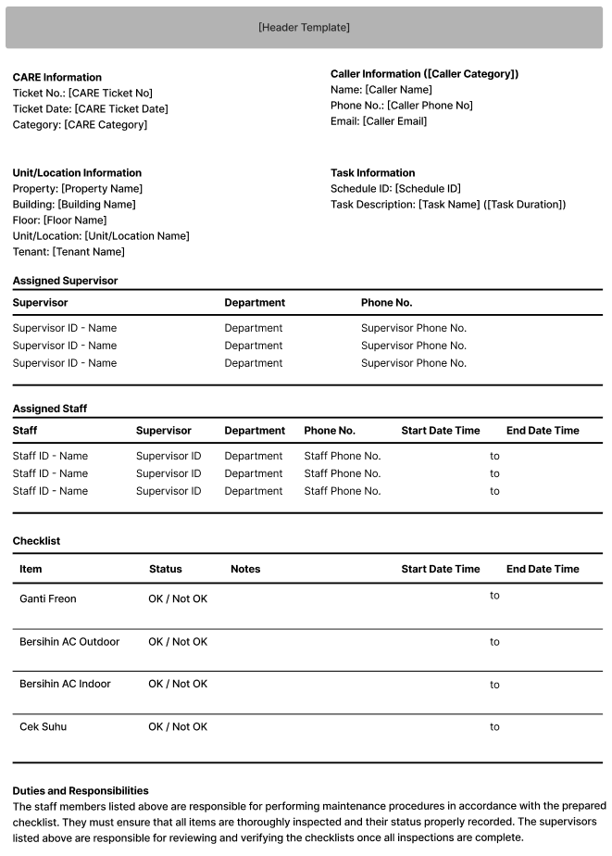

PAPER SIZE: A4 PORTRAIT  
REPORT TYPE: ‘02’ – NON MAINTENANCE

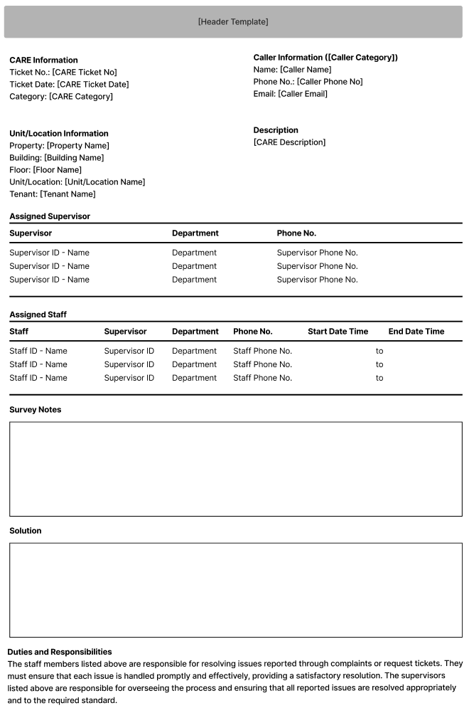

#### INPUT PARAMETER

|  |  |
| --- | --- |
| **Parameter Name** | **Description** |
| PARAM_SELECTED_CARE | VAR_SELECTED_CARE from TAB CARE PROCESS |

#### ROLES

|  |  |
| --- | --- |
|  | **Test** |
| * User yg punya akses ke program |  |

#### REPORT DEFINITION

|  |  |  |  |
| --- | --- | --- | --- |
| **Section** | **Name** | **Field** | **Validation** |
| HEADER TEMPLATE | Title |  | “CARE” |
| CARE Information | Ticket No. | CCARE_TICKET_NO |  |
| Ticket Date | DCARE_TICKET_DATE |  |
| Category | CCARE_CATEGORY |  |
| Caller Information | (Caller Category) | CCALLER_CATEGORY_DESCRIPTION, CCALLER_SUBCATEGORY | Set Display:  IF CCALLER_SUBCATEGORY is not EMPTY, then  “CCALLER_CATEGORY (CCALLER_SUBCATEGORY)”  Else,  “CCALLER_CATEGORY_DESCRIPTION” |
| Name | CCALLER_NAME |  |
| Phone No. | CCALLER_PHONE |  |
| Email | CCALLER_EMAIL |  |
| Unit/Location Information  If CAREA = ‘01’, then “Unit Information”  Else, “Location Information | Property | CPROPERTY_NAME |  |
| Building | CBUILDING_NAME |  |
| Floor | CFLOOR_NAME |  |
| Unit/Location | CUNIT_LOCATION_NAME | IF CAREA = ‘01’, “Unit”  Else, “Location” |
| Tenant | CTENANT_NAME | Hidden on,  CAREA = ‘02’ |
| Task Information  Hidden on,  CCARE_CATEGORY <> ‘01’ | Schedule ID | CSCHEDULE_ID |  |
| Task Description | CTASK_NAME, CTASK_DURATION | “CTASK_NAME (CTASK_DURATION)” |
|  |  |  |  |
| Assigned Supervisor  GROUP BY LCHECKLIST = 0 &  LSUPERVISOR = 1 | Supervisor | CSUPERVISOR_ID, CSUPERVISOR_NAME | “CSUPERVISOR_ID – CSUPERVISOR_NAME” |
| Department | CSUPERVISOR_DEPT_CODE |  |
| Phone No. | CSUPERVISOR_PHONE |  |
|  |  |  |  |
| Assigned Staff  GROUP BY LCHECKLIST = 0 &  LSUPERVISOR = 0 | Staff | CSTAFF_ID, CSTAFF_NAME | “CSTAFF_ID – CSTAFF_NAME” |
| Supervisor | CSTAFF_SUPERVISOR_ID |  |
| Department | CSTAFF_DEPT_CODE |  |
| Phone No. | CSTAFF_PHONE |  |
| Start Date Time |  |  |
|  |  | “to” |
| End Date TIme |  |  |
|  |  |  |  |
| Checklist  GROUP BY LCHECKLIST = 1 | Item | CITEM |  |
| Status |  | “OK / Not OK” |
| Notes |  |  |
| Start Date Time |  |  |
|  |  | “to” |
| End Date Time |  |  |
|  |  |  |  |
| Duties and Responsibilities | IF CCARE_CATEGORY = ‘01’  The staff members listed above are responsible for performing maintenance procedures in accordance with the prepared checklist. They must ensure that all items are thoroughly inspected and their status properly recorded. The supervisors listed above are responsible for reviewing and verifying the checklists once all inspections are complete.  ELSE  The staff members listed above are responsible for resolving issues reported through complaints or request tickets. They must ensure that each issue is handled promptly and effectively, providing a satisfactory resolution. The supervisors listed above are responsible for overseeing the process and ensuring that all reported issues are resolved appropriately and to the required standard. | | |

#### VALIDATION

|  |  |  |
| --- | --- | --- |
| **Field** | **Condition** | **Validation Message** |
|  |  |  |

#### ACTION

|  |
| --- |
|  |
| * **Validate** (See VALIDATION table)   IF Success, jalankan **Get Report Data**  IF Failed, do nothing   * **Get Report Data**   Jalankan RSP_HD_GET_CARE_REPORT dengan parameter,  @CCOMPANY_ID = VAR_COMPANY_ID  @CPROPERTY_ID = FORM_DATA.CPROPERTY_ID  @CCARE_TICKET_NO = FORM_DATA.CCARE_TICKET_NO  @CLANG_ID = VAR_LANG_ID  Ex.  EXEC RSP_HD_GET_CARE_REPORT  ‘BSI’  , ‘ASHMD’  , ‘CARE-001’ |
| * Proses:   + ‘Print’ 🡪 Display Report PDF File in new tab |

### REVIEW CHARGES PROCESS (DETAIL TAB)

#### USER INTERFACE

##### INITIAL VERSION

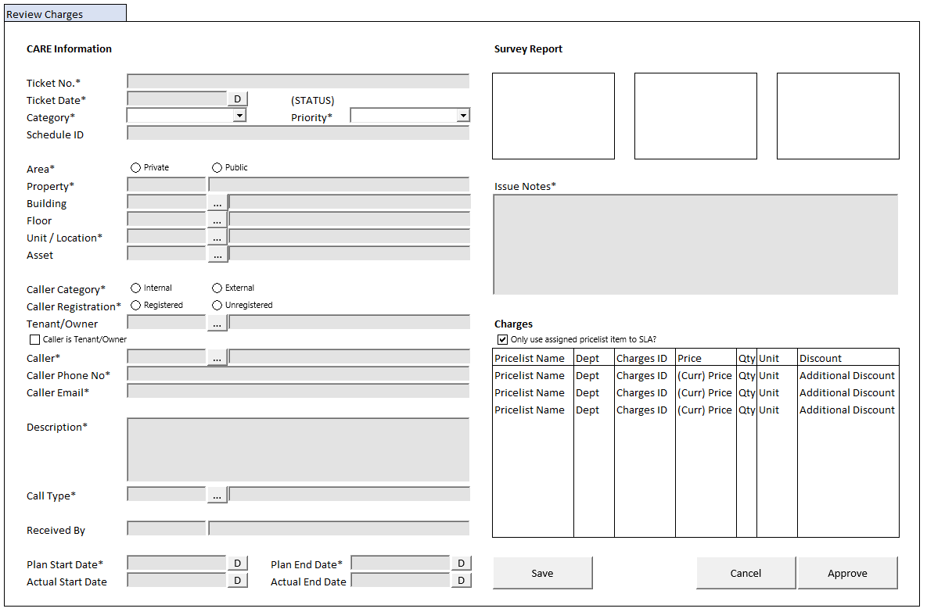

#### BUTTON DEFINITION

|  |  |  |
| --- | --- | --- |
| **Button Name** | **Action** | **Enabled** |
| Save | Jalankan SAVE PROCESS |  |
| Cancel | Jalankan CANCEL PROCESS |  |
| Approve | Jalankan APPROVE PROCESS |  |

#### INPUT PARAMETER

|  |  |
| --- | --- |
| **Parameter Name** | **Description** |
| PARAM_SELECTED_PROPERTY | VAR_SELECTED_PROPERTY from TAB CARE PROCESS |
| PARAM_SELECTED_CARE | VAR_SELECTED_CARE from TAB CARE PROCESS |

#### ROLES

|  |  |
| --- | --- |
|  | **Test** |
| * User yg punya akses ke program |  |

#### INITIAL PROCESS

|  |  |
| --- | --- |
|  | **Test** |
| * Load data from Input Parameter * Set VAR_CHARGES_LIST = Empty List * **Load CARE Detail**   Jalankan RSP_HD_GET_CARE_DETAIL dengan parameter, simpan hasil ke FORM_DATA   * + VAR_COMPANY_ID   + VAR_SELECTED_PROPERTY.CPROPERTY_ID   + PARAM_SELECTED_CARE.CCARE_TICKET_NO   + VAR_LANG_ID * **Load CARE Charges List**   Jalankan RSP_HD_GET_CARE_CHARGES_LIST dengan parameter, simpan hasil ke VAR_CHARGES_LIST   * + VAR_COMPANY_ID   + VAR_SELECTED_PROPERTY.CPROPERTY_ID   + PARAM_SELECTED_CARE.CCARE_TICKET_NO   + VAR_LANG_ID |  |

#### DISPLAY PROCESS

##### FIELD DEFINITION

|  |  |  |  |
| --- | --- | --- | --- |
| **Name** | **Field** | **Type** | **Validation** |
| **Display Form** |  | **Data**: FORM_DATA |  |
| **CARE Information** |  |  |  |
| Ticket No. | CCARE_TICKET_NO | Textbox, Disabled, Required |  |
| Ticket Date | DCARE_TICKET_DATE | DateTimePicker, Disabled, Required |  |
| (STATUS) | CSTATUS, CSUBSTATUS  Set Display:  IF CSTATUS = ‘04’, then  ~~CSTATUS_DESCRIPTION~~ ~~(CSUBSTATUS_DESCRIPTION)~~  CSUBSTATUS_DESCRIPTION **[CR01]**  Else  CSTATUS_DESCRIPTION | Label, **BOLD** |  |
| Category | CCARE_CATEGORY | Combobox, Disabled, Required  Isi combobox dengan **VAR_CARE_CATEGORY**  Set ValueField = CCODE  Set TextField = CNAME  Simpan hasil ke CCARE_CATEGORY |  |
| Priority | CPRIORITY | Combobox, Disabled, Required  Isi combobox dengan **VAR_PRIORITY**  Set ValueField = CCODE  Set TextField = CNAME  Simpan hasil ke CPRIORITY |  |
| Schedule ID | CSCHEDULE_ID | Textbox, Disabled | Hidden on,  CCARE_CATEGORY <> ‘01’ |
| Area | CAREA | Radiobutton, Disabled, Required  Isi radiobutton dengan **VAR_AREA**  Set ValueField = CCODE  Set TextField = CNAME  Simpan hasil ke CAREA |  |
| Property | Set CPROPERTY_ID = PARAM_SELECTED_PROPERTY. CPROPERTY_ID | Textbox, Disabled, Required |  |
|  | Set CPROPERTY_NAME = PARAM_SELECTED_PROPERTY. CPROPERTY_NAME | Textbox, Disabled |  |
| Building | CBUILDING_ID | Textbox, Disabled |  |
|  |  | Lookup, Disabled |  |
|  | CBUILDING_NAME | Textbox, Disabled |  |
| Floor | CFLOOR_ID | Textbox, Disabled |  |
|  |  | Lookup, Disabled |  |
|  | CFLOOR_NAME | Textbox, Disabled |  |
| Unit/Location | CUNIT_LOCATION_ID | Textbox, Disabled, Required |  |
|  |  | Lookup, Disabled |  |
|  | CUNIT_LOCATION_NAME | Textbox, Disabled |  |
| Asset | CASSET_ID | Textbox, Disabled |  |
|  |  | Lookup, Disabled |  |
|  | CASSET_NAME | Textbox, Disabled |  |
| Caller Category | CCALLER_CATEGORY | Radiobutton, Disabled, Required  Isi radiobutton dengan **VAR_CALLER_CATEGORY**  Set ValueField = CCODE  Set TextField = CNAME  Simpan hasil ke CCALLER_CATEGORY |  |
| Caller Registration | CCALLER_REGISTRATION | Radiobutton, Disabled, Required  Isi radiobutton dengan **VAR_CALLER_REGISTRAION**  Set ValueField = CCODE  Set TextField = CNAME  Simpan hasil ke CCALLER_REGISTRATION |  |
| Tenant/Owner | CTENANT_OWNER_ID | Textbox, Disabled |  |
|  |  | Lookup, Disabled |  |
|  | CTENANT_OWNER_NAME | Textbox, Disabled |  |
|  | CTENANT_OWNER_PHONE | Hidden |  |
|  | CTENANT_OWNER_EMAIL | Hidden |  |
| Caller is Tenant/Owner | LCALLER_IS_TENANT | Checkbox, Disabled, Required |  |
| Caller | CCALLER_ID | Textbox, Disabled, Required |  |
|  |  | Lookup, Disabled |  |
|  | CCALLER_NAME | Textbox, Disabled, Required |  |
| Caller Phone No | CCALLER_PHONE | Textbox, Disabled, Required |  |
| Caller Email | CCALLER_EMAIL | Textbox, Disabled, Required |  |
| Description | CCARE_DESCRIPTION | Textarea, Disabled, Required |  |
| Call Type | CCALL_TYPE_ID | Textbox, Disabled, Required |  |
|  |  | Lookup, Disabled |  |
|  | CCALL_TYPE_NAME | Textbox, Disabled |  |
| Call Type Days | CCALL_TYPE_DAYS | Hidden |  |
| Call Type Hours | CCALL_TYPE_HOURS | Hidden |  |
| Call Type Minutes | CCALL_TYPE_MINUTES | Hidden |  |
| Submitted By | CRECEIVED_BY | Textbox, Disabled |  |
|  | DRECEIVED_DATE | DateTimePicker, Disabled |  |
| Plan Start Date | DPLAN_START_DATE | DateTimePicker, Disabled, Required |  |
| Plan End Date | DPLAN_END_DATE | DateTimePicker, Disabled |  |
| Actual Start Date | DACTUAL_START_DATE | DateTimePicker, Disabled |  |
| Actual End Date | DACTUAL_END_DATE | DateTimePicker, Disabled |  |
| **Survey Report** |  |  |  |
| Image 1 | CSURVEY_IMAGE_1_STORAGE_ID | ImageBox | On Clicked,  IF CSURVEY_IMAGE_1_STORAGE_ID is not EMPTY, Go To 🡪 ZOOM IMAGE PROCESS |
| Image 2 | CSURVEY_IMAGE_2_STORAGE_ID | ImageBox | On Clicked,  IF CSURVEY_IMAGE_2_STORAGE_ID is not EMPTY, Go To 🡪 ZOOM IMAGE PROCESS |
| Image 3 | CSURVEY_IMAGE_3_STORAGE_D | ImageBox | On Clicked,  IF CSURVEY_IMAGE_3_STORAGE_ID is not EMPTY, Go To 🡪 ZOOM IMAGE PROCESS |
|  | LSURVEY_NOTES_EDITABLE | Hidden |  |
| Issue Notes | CSURVEY_NOTES | Textarea, Required | Enabled on,  LSURVEY_NOTES_EDITABLE = TRUE  Max Length = 1000 |
| **Charges** |  |  |  |
| Only use assigned pricelist item to SLA? | LSEARCH_WITH_SLA | Checkbox | Set Default = TRUE |

##### GRID DEFINITION

|  |  |  |  |
| --- | --- | --- | --- |
| **Name** | **Field** | **Type** | **Validation** |
| **Charges Grid** |  | **Data**: VAR_CHARGES_LIST  **Type:** Original | Allow:  ADD 🡪 Tambahkan Charges ke VAR_CHARGES_LIST  EDIT 🡪 Ubah selected Charges dari VAR_CHARGES_LIST  DELETE 🡪 Hapus Charges dari VAR_CHARGES_LIST  On Selected Changed,  Set **VAR_SELECTED_CHARGES** = Selected Row’s Data |
| **Charges** |  |  |  |
| Pricelist Name | CPRICELIST_NAME | Textbox, Disabled, Required |  |
|  |  | Lookup, Disabled | Enabled: On ADD  On Lookup Button Clicked,  Go to 🡪 PRICELIST ITEM LOOKUP PROCESS  On Lookup Process Successful, update:  CPRICELIST_NAME, CPRICELIST_ID, CVALID_ID, CDEPT_CODE, CCHARGES_ID, IPRICE, CCURRENCY_CODE, CUNIT |
|  | CPRICELIST_ID | Hidden, Required |  |
|  | CVALID_ID | Hidden, Required |  |
| Dept | CDEPT_CODE | Textbox, Disabled, Required |  |
| Charges ID | CCHARGES_ID | Textbox, Disabled, Required |  |
| Price (FROM_DATA. CCURRENCY_CODE) | IPRICE | NumericTextbox, Disabled, Required | Decimal Places = 2  Thousand Separator = Enabled |
| Qty | IQUANTITY | NumericTextbox, Disabled, Required | Enabled: On ADD & EDIT  Decimal Places = 0  Thousand Separator = Enabled |
| Unit | CUNIT | Textbox, Disabled, Required |  |
| Discount  (FROM_DATA. CCURRENCY_CODE) | IDISCOUNT | NumericTextbox, Disabled | Enabled: On ADD & EDIT  Decimal Places = 2  Thousand Separator = Enabled  Set Default = 0 |

#### ZOOM IMAGE PROCESS (POPUP)

##### USER INTERFACE

###### INITIAL VERSION

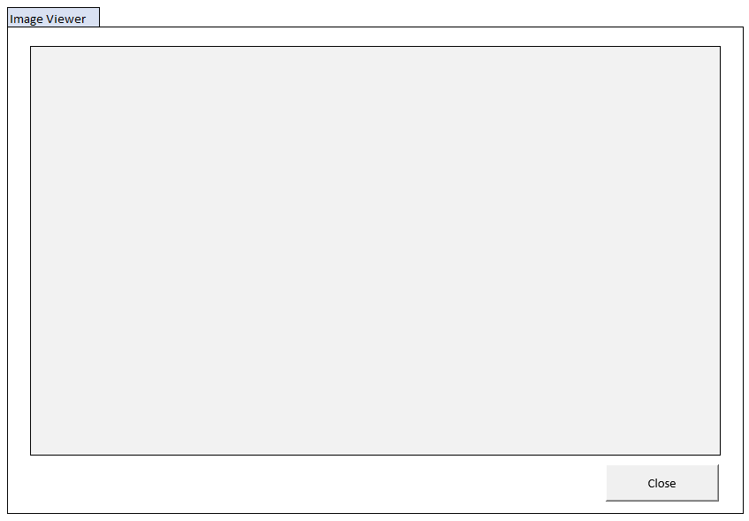

##### BUTTON DEFINITION

|  |  |  |
| --- | --- | --- |
| **Button Name** | **Action** | **Enabled** |
| Close | Close this popup |  |

##### INPUT PARAMETER

|  |  |
| --- | --- |
| **Parameter Name** | **Description** |
| PARAM_IMAGE | IMAGE_DATA from Image Box from DETAIL TAB |

##### ROLES

|  |  |
| --- | --- |
|  | **Test** |
| * User yg punya akses ke program |  |

##### INITIAL PROCESS

|  |  |
| --- | --- |
|  | **Test** |
| * Load data from Input Parameter |  |

##### DISPLAY PROCESS

###### FIELD DEFINITION

|  |  |  |  |
| --- | --- | --- | --- |
| **Name** | **Field** | **Type** | **Validation** |
| Image Viewer | PARAM_IMAGE | ImageBox | MaxWidth: 1000px  MaxHeight: 800px |

#### CANCEL PROCESS

##### ACTION

|  |
| --- |
|  |
| * Close this DETAIL TAB |
|  |

#### SAVE PROCESS

##### VALIDATION

|  |  |  |
| --- | --- | --- |
| **Field** | **Condition** | **Validation Message** |
| Issue Notes | CSURVEY_NOTES is Empty | Please fill Issue Notes! |

##### ACTION

|  |
| --- |
|  |
| * **Validate** (See VALIDATION table)   IF Success, jalankan **Save CARE Survey**  IF Failed, stay on Detail Tab   * Set **Progess bar step** = 4 * Set **VAR_KEY_GUID** = New GUID * Set **VAR_ERROR_COUNT** = 0 * Reset Progress Bar |
| **BEGIN TRANSACTION**   * Buat temporary table   CREATE TABLE #ADD_CARE_CHARGES (  NO INT NOT NULL  , CPRICELIST_ID VARCHAR(20) NOT NULL  , CVALID_ID VARCHAR(26) NOT NULL  , IQUANTITY INT NOT NULL  , IDISCOUNT INT NOT NULL  )   * Insert **VAR_CHARGES_LIST** into #ADD_CARE_CHARGES * **Save CARE Survey**   Jalankan RSP_HD_MAINTAIN_CARE_SURVEY dengan parameter  @CCOMPANY_ID = VAR_COMPANY_ID  @CPROPERTY_ID = FORM_DATA.CPROPERTY_ID  @CCARE_TICKET_NO = FORM_DATA.CCARE_TICKET_NO  @CSURVEY_NOTES = FORM_DATA.CSURVEY_NOTES  @CACTION = ‘SAVE’  @CUSER_ID = VAR_USER_ID  @CKEY_GUID = VAR_KEY_GUID  **COMPLETE TRANSACTION** |
| * Close this DETAIL TAB * Refresh **CARE Grid** di TAB CARE PROCESS |

#### APPROVE PROCESS

##### VALIDATION

|  |  |  |
| --- | --- | --- |
| **Field** | **Condition** | **Validation Message** |
| Issue Notes | CSURVEY_NOTES is Empty | Please fill Issue Notes! |
| Charges | VAR_CHARGES_LIST’s length < 1 | Please add at least 1 Pricelist Item! |
| Qty | At least 1 item of VAR_CHARGES_LIST’s IQUANTITY is Empty or 0 | Please add quantity to Pricelist Item, quantity cannot be 0 or negative value! |

##### ACTION

|  |
| --- |
|  |
| * **Validate** (See VALIDATION table)   IF Success, jalankan **Approve CARE Survey**  IF Failed, stay on Detail Tab   * Set **Progess bar step** = 4 * Set **VAR_KEY_GUID** = New GUID * Set **VAR_ERROR_COUNT** = 0 * Reset Progress Bar |
| **BEGIN TRANSACTION**   * Buat temporary table   CREATE TABLE #ADD_CARE_CHARGES (  NO INT NOT NULL  , CPRICELIST_ID VARCHAR(20) NOT NULL  , CVALID_ID VARCHAR(26) NOT NULL  , IQUANTITY INT NOT NULL  , IDISCOUNT INT NOT NULL  )   * Insert **VAR_CHARGES_LIST** into #ADD_CARE_CHARGES * **Approve CARE Survey**   Jalankan RSP_HD_MAINTAIN_CARE_SURVEY dengan parameter  @CCOMPANY_ID = VAR_COMPANY_ID  @CPROPERTY_ID = FORM_DATA.CPROPERTY_ID  @CCARE_TICKET_NO = FORM_DATA.CCARE_TICKET_NO  @CSURVEY_NOTES = FORM_DATA.CSURVEY_NOTES  @CACTION = ‘APPROVE’  @CUSER_ID = VAR_USER_ID  @CKEY_GUID = VAR_KEY_GUID  **COMPLETE TRANSACTION** |
| * Close this DETAIL TAB * Refresh **CARE Grid** di TAB CARE PROCESS |

### TENANT CONFIRMATION PROCESS (DETAIL TAB)

#### USER INTERFACE

##### INITIAL VERSION

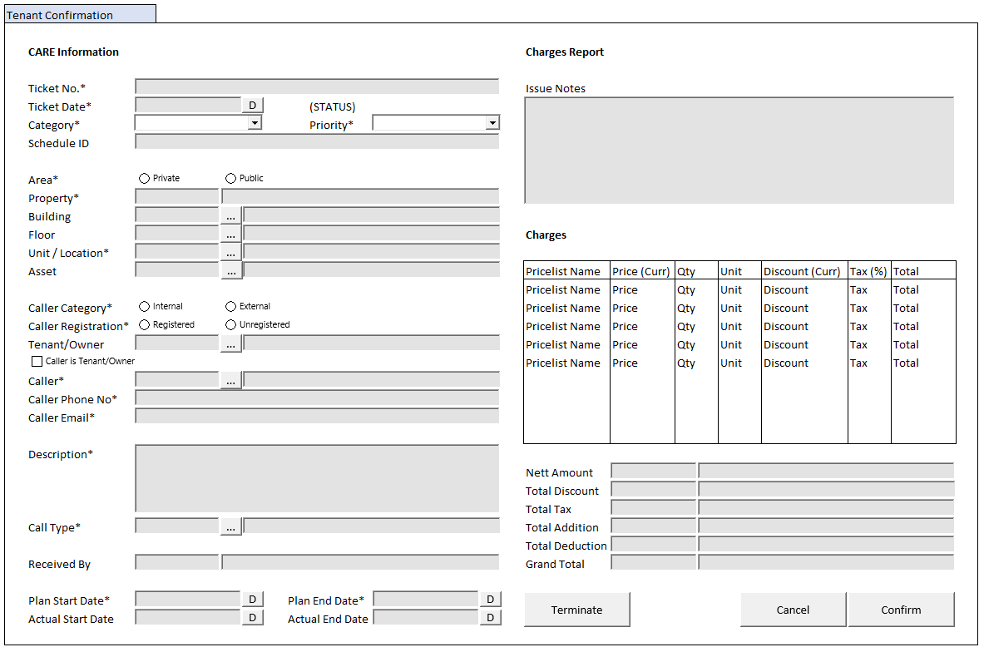

#### BUTTON DEFINITION

|  |  |  |
| --- | --- | --- |
| **Button Name** | **Action** | **Enabled** |
| Terminate | Jalankan TERMINATE PROCESS |  |
| Cancel | Jalankan CANCEL PROCESS |  |
| Confirm | Jalankan CONFIRM PROCESS |  |

#### INPUT PARAMETER

|  |  |
| --- | --- |
| **Parameter Name** | **Description** |
| PARAM_SELECTED_PROPERTY | VAR_SELECTED_PROPERTY from TAB CARE PROCESS |
| PARAM_SELECTED_CARE | VAR_SELECTED_CARE from TAB CARE PROCESS |

#### ROLES

|  |  |
| --- | --- |
|  | **Test** |
| * User yg punya akses ke program |  |

#### INITIAL PROCESS

|  |  |
| --- | --- |
|  | **Test** |
| * Load data from Input Parameter * Set VAR_CHARGES_LIST = Empty List * **Load CARE Detail**   Jalankan RSP_HD_GET_CARE_DETAIL dengan parameter, simpan hasil ke FORM_DATA   * + VAR_COMPANY_ID   + VAR_SELECTED_PROPERTY.CPROPERTY_ID   + PARAM_SELECTED_CARE.CCARE_TICKET_NO   + VAR_LANG_ID * **Load CARE Charges List**   Jalankan RSP_HD_GET_CARE_CHARGES_LIST dengan parameter, simpan hasil ke VAR_CHARGES_LIST   * + VAR_COMPANY_ID   + VAR_SELECTED_PROPERTY.CPROPERTY_ID   + PARAM_SELECTED_CARE.CCARE_TICKET_NO   + VAR_LANG_ID * **Load Total Amount**   Jalankan RSP_HD_GET_CARE_INVOICE_TOTAL dengan parameter, simpan hasil ke VAR_CARE_INVOICE_TOTAL   * + VAR_COMPANY_ID   + VAR_SELECTED_PROPERTY.CPROPERTY_ID   + PARAM_SELECTED_CARE.CCARE_TICKET_NO   + VAR_LANG_ID |  |

#### DISPLAY PROCESS

##### FIELD DEFINITION

|  |  |  |  |
| --- | --- | --- | --- |
| **Name** | **Field** | **Type** | **Validation** |
| **Display Form** |  | **Data**: FORM_DATA |  |
| **CARE Information** |  |  |  |
| Ticket No. | CCARE_TICKET_NO | Textbox, Disabled, Required |  |
| Ticket Date | DCARE_TICKET_DATE | DateTimePicker, Disabled, Required |  |
| (STATUS) | CSTATUS, CSUBSTATUS  Set Display:  IF CSTATUS = ‘04’, then  ~~CSTATUS_DESCRIPTION~~ ~~(CSUBSTATUS_DESCRIPTION)~~  CSUBSTATUS_DESCRIPTION **[CR01]**  Else  CSTATUS_DESCRIPTION | Label, **BOLD** |  |
| Category | CCARE_CATEGORY | Combobox, Disabled, Required  Isi combobox dengan **VAR_CARE_CATEGORY**  Set ValueField = CCODE  Set TextField = CNAME  Simpan hasil ke CCARE_CATEGORY |  |
| Priority | CPRIORITY | Combobox, Disabled, Required  Isi combobox dengan **VAR_PRIORITY**  Set ValueField = CCODE  Set TextField = CNAME  Simpan hasil ke CPRIORITY |  |
| Schedule ID | CSCHEDULE_ID | Textbox, Disabled | Hidden on,  CCARE_CATEGORY <> ‘01’ |
| Area | CAREA | Radiobutton, Disabled, Required  Isi radiobutton dengan **VAR_AREA**  Set ValueField = CCODE  Set TextField = CNAME  Simpan hasil ke CAREA |  |
| Property | Set CPROPERTY_ID = PARAM_SELECTED_PROPERTY. CPROPERTY_ID | Textbox, Disabled, Required |  |
|  | Set CPROPERTY_NAME = PARAM_SELECTED_PROPERTY. CPROPERTY_NAME | Textbox, Disabled |  |
| Building | CBUILDING_ID | Textbox, Disabled |  |
|  |  | Lookup, Disabled |  |
|  | CBUILDING_NAME | Textbox, Disabled |  |
| Floor | CFLOOR_ID | Textbox, Disabled |  |
|  |  | Lookup, Disabled |  |
|  | CFLOOR_NAME | Textbox, Disabled |  |
| Unit/Location | CUNIT_LOCATION_ID | Textbox, Disabled, Required |  |
|  |  | Lookup, Disabled |  |
|  | CUNIT_LOCATION_NAME | Textbox, Disabled |  |
| Asset | CASSET_ID | Textbox, Disabled |  |
|  |  | Lookup, Disabled |  |
|  | CASSET_NAME | Textbox, Disabled |  |
| Caller Category | CCALLER_CATEGORY | Radiobutton, Disabled, Required  Isi radiobutton dengan **VAR_CALLER_CATEGORY**  Set ValueField = CCODE  Set TextField = CNAME  Simpan hasil ke CCALLER_CATEGORY |  |
| Caller Registration | CCALLER_REGISTRATION | Radiobutton, Disabled, Required  Isi radiobutton dengan **VAR_CALLER_REGISTRAION**  Set ValueField = CCODE  Set TextField = CNAME  Simpan hasil ke CCALLER_REGISTRATION |  |
| Tenant/Owner | CTENANT_OWNER_ID | Textbox, Disabled |  |
|  |  | Lookup, Disabled |  |
|  | CTENANT_OWNER_NAME | Textbox, Disabled |  |
|  | CTENANT_OWNER_PHONE | Hidden |  |
|  | CTENANT_OWNER_EMAIL | Hidden |  |
| Caller is Tenant/Owner | LCALLER_IS_TENANT | Checkbox, Disabled, Required |  |
| Caller | CCALLER_ID | Textbox, Disabled, Required |  |
|  |  | Lookup, Disabled |  |
|  | CCALLER_NAME | Textbox, Disabled, Required |  |
| Caller Phone No | CCALLER_PHONE | Textbox, Disabled, Required |  |
| Caller Email | CCALLER_EMAIL | Textbox, Disabled, Required |  |
| Description | CCARE_DESCRIPTION | Textarea, Disabled, Required |  |
| Call Type | CCALL_TYPE_ID | Textbox, Disabled, Required |  |
|  |  | Lookup, Disabled |  |
|  | CCALL_TYPE_NAME | Textbox, Disabled |  |
| Call Type Days | CCALL_TYPE_DAYS | Hidden |  |
| Call Type Hours | CCALL_TYPE_HOURS | Hidden |  |
| Call Type Minutes | CCALL_TYPE_MINUTES | Hidden |  |
| Submitted By | CRECEIVED_BY | Textbox, Disabled |  |
|  | DRECEIVED_DATE | DateTimePicker, Disabled |  |
| Plan Start Date | DPLAN_START_DATE | DateTimePicker, Disabled, Required |  |
| Plan End Date | DPLAN_END_DATE | DateTimePicker, Disabled |  |
| Actual Start Date | DACTUAL_START_DATE | DateTimePicker, Disabled |  |
| Actual End Date | DACTUAL_END_DATE | DateTimePicker, Disabled |  |
| **Survey Report** |  |  |  |
| Issue Notes | CSURVEY_NOTES | Textarea, Disabled, Required | Max Length = 1000 |
| **Charges** |  | **Data**: VAR_CARE_INVOICE_TOTAL |  |
| Nett Amount | CCURRENCY_CODE | Textbox, Disabled |  |
|  | NNET_AMOUNT | NumericTextbox, Disabled | Decimal Places = 2  Thousand Separator = Enabled |
| Total Discount | CCURRENCY_CODE | Textbox, Disabled |  |
|  | NTOTAL_DISCOUNT | NumericTextbox, Disabled | Decimal Places = 2  Thousand Separator = Enabled |
| Total Tax | CCURRENCY_CODE | Textbox, Disabled |  |
|  | NTOTAL_TAX | NumericTextbox, Disabled | Decimal Places = 2  Thousand Separator = Enabled |
| Total Addition | CCURRENCY_CODE | Textbox, Disabled |  |
|  | NTOTAL_ADD | NumericTextbox, Disabled | Decimal Places = 2  Thousand Separator = Enabled |
| Total Deduction | CCURRENCY_CODE | Textbox, Disabled |  |
|  | NTOTAL_DED | NumericTextbox, Disabled | Decimal Places = 2  Thousand Separator = Enabled |
| Grand Total | CCURRENCY_CODE | Textbox, Disabled |  |
|  | NGRAND_TOTAL | NumericTextbox, Disabled | Decimal Places = 2  Thousand Separator = Enabled |

##### GRID DEFINITION

|  |  |  |  |
| --- | --- | --- | --- |
| **Name** | **Field** | **Type** | **Validation** |
| **Charges Grid** |  | **Data**: VAR_CHARGES_LIST  **Type:** Original | Allow:  EDIT 🡪 EDIT CHARGES PROCESS  On Selected Changed,  Set **VAR_SELECTED_CHARGES** = Selected Row’s Data |
| **Charges** |  |  |  |
| Pricelist Name | CPRICELIST_NAME | Textbox, Disabled, Required |  |
|  | CPRICELIST_ID | Hidden, Required |  |
|  | CVALID_ID | Hidden, Required |  |
| Price  (FROM_DATA. CCURRENCY_CODE) | IPRICE | NumericTextbox, Disabled, Required | Decimal Places = 2  Thousand Separator = Enabled |
| Qty | IQUANTITY | NumericTextbox, Disabled, Required | Decimal Places = 0  Thousand Separator = Enabled |
| Unit | CUNIT | Textbox, Disabled, Required |  |
| Discount  (FROM_DATA. CCURRENCY_CODE) | IDISCOUNT | NumericTextbox, Disabled | Enabled: On EDIT  Decimal Places = 2  Thousand Separator = Enabled |
| Tax  (%) | NTAX_PCT | NumericTextbox, Disabled | Decimal Places = 2 |
| Total | NTOTAL_AMOUNT | NumericTextBox, Disabled | Decimal Places = 2 |

#### EDIT CHARGES PROCESS

##### VALIDATION

|  |  |  |
| --- | --- | --- |
| **Field** | **Condition** | **Validation Message** |
|  |  |  |

##### ACTION

|  |
| --- |
|  |
| * **Validate** (See VALIDATION table)   IF Success, jalankan **Edit Charges**  IF Failed, stay on Detail Tab |
| * **Edit Charges**   Jalankan RSP_HD_MAINTAIN_CARE_CHARGES dengan parameter  @CCOMPANY_ID = VAR_COMPANY_ID  @CPROPERTY_ID = FORM_DATA.CPROPERTY_ID  @CCARE_TICKET_NO = FORM_DATA.CCARE_TICKET_NO  @CPRICELIST_ID = VAR_SELECTED_CHARGES.CPRICELIST_ID  @CVALID_ID = VAR_SELECTED_CHARGES.CVALID_ID  @IQUANTITY = VAR_SELECTED_CHARGES.IQUANTITY  @IDISCOUNT = VAR_SELECTED_CHARGES.IDISCOUNT  @CUSER_ID = VAR_USER_ID |
|  |

#### CANCEL PROCESS

##### ACTION

|  |
| --- |
|  |
| * Close this DETAIL TAB |
|  |

#### TERMINATE PROCESS

##### VALIDATION

|  |  |  |
| --- | --- | --- |
| **Field** | **Condition** | **Validation Message** |
|  |  |  |

##### ACTION

|  |
| --- |
|  |
| * **Confirmation**   Show Message “Are you sure want to terminate this CARE?” (YES/NO)  IF YES, jalankan **Terminate CARE**  IF NO, stay on Detail Tab |
| * **Terminate CARE**   Jalankan RSP_HD_CARE_PROCESS dengan parameter  @CCOMPANY_ID = VAR_COMPANY_ID  @CPROPERTY_ID = FORM_DATA.CPROPERTY_ID  @CCARE_TICKET_NO = FORM_DATA.CCARE_TICKET_NO  @CACTION = ‘01’  @CUSER_ID = VAR_USER_ID |
| * Close this DETAIL TAB * Refresh **CARE Grid** di TAB CARE PROCESS |

#### CONFIRM PROCESS

##### VALIDATION

|  |  |  |
| --- | --- | --- |
| **Field** | **Condition** | **Validation Message** |
|  |  |  |

##### ACTION

|  |
| --- |
|  |
| * **Validate** (See VALIDATION table)   IF Success, jalankan **Confirm CARE**  IF Failed, stay on Detail Tab |
| * **Confirm CARE**   Jalankan RSP_HD_CARE_PROCESS dengan parameter  @CCOMPANY_ID = VAR_COMPANY_ID  @CPROPERTY_ID = FORM_DATA.CPROPERTY_ID  @CCARE_TICKET_NO = FORM_DATA.CCARE_TICKET_NO  @CACTION = ‘02’  @CUSER_ID = VAR_USER_ID |
| * Close this DETAIL TAB * Refresh **CARE Grid** di TAB CARE PROCESS |

### COMPLETE CARE PROCESS (DETAIL TAB)

#### USER INTERFACE

##### INITIAL VERSION

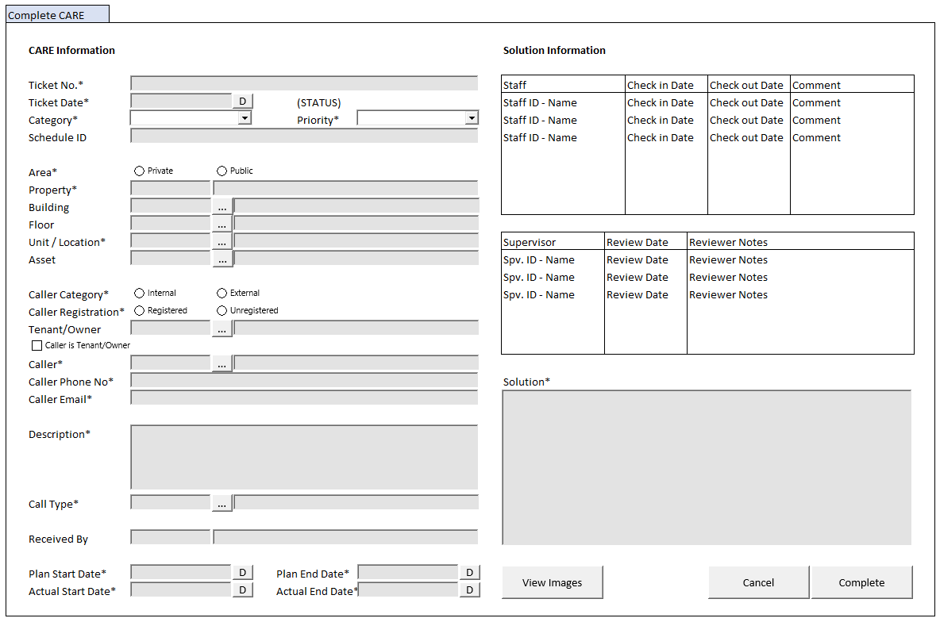

#### BUTTON DEFINITION

|  |  |  |
| --- | --- | --- |
| **Button Name** | **Action** | **Enabled** |
| View Images | Jalankan VIEW IMAGES PROCESS | * FORM_DATA.LVIEW_IMAGES = TRUE * HIDDEN on   FORM_DATA.CCARE_CATEGORY = ‘01’ |
| View Checklist | Jalankan VIEW CHECKLIST PROCESS | * FORM_DATA.LVIEW_CHECKLIST = TRUE * HIDDEN on   CCARE_CATEGORY <> ‘01’ |
| Cancel | Jalankan CANCEL PROCESS |  |
| Save | Jalankan COMPLETE PROCESS |  |

#### INPUT PARAMETER

|  |  |
| --- | --- |
| **Parameter Name** | **Description** |
| PARAM_SELECTED_PROPERTY | VAR_SELECTED_PROPERTY from TAB CARE PROCESS |
| PARAM_SELECTED_CARE | VAR_SELECTED_CARE from TAB CARE PROCESS |

#### ROLES

|  |  |
| --- | --- |
|  | **Test** |
| * User yg punya akses ke program |  |

#### INITIAL PROCESS

|  |  |
| --- | --- |
|  | **Test** |
| * Load data from Input Parameter * **Load CARE Detail**   Jalankan RSP_HD_GET_CARE_DETAIL dengan parameter, simpan hasil ke FORM_DATA   * + VAR_COMPANY_ID   + VAR_SELECTED_PROPERTY.CPROPERTY_ID   + PARAM_SELECTED_CARE.CCARE_TICKET_NO   + VAR_LANG_ID * **Load Supervisor List**   Jalankan RSP_HD_GET_CARE_SUPERVISOR_LIST dengan parameter, simpan hasil ke VAR_SUPERVISOR_LIST dan VAR_SELECTED_SUPERVISOR   * + VAR_COMPANY_ID   + VAR_SELECTED_PROPERTY.CPROPERTY_ID   + VAR_SELECTED_CARE.CCARE_TICKET_NO   + VAR_LANG_ID * **Load Staff List**   Jalankan RSP_HD_GET_CARE_STAFF_LIST dengan parameter, simpan hasil ke VAR_STAFF_LIST dan VAR_SELECTED_STAFF   * + VAR_COMPANY_ID   + VAR_SELECTED_PROPERTY.CPROPERTY_ID   + VAR_SELECTED_CARE.CCARE_TICKET_NO   + ‘’   + VAR_LANG_ID |  |

#### DISPLAY PROCESS

##### FIELD DEFINITION

|  |  |  |  |
| --- | --- | --- | --- |
| **Name** | **Field** | **Type** | **Validation** |
| **Display Form** |  | **Data**: FORM_DATA |  |
| **CARE Information** |  |  |  |
| Ticket No. | CCARE_TICKET_NO | Textbox, Disabled, Required |  |
| Ticket Date | DCARE_TICKET_DATE | DateTimePicker, Disabled, Required |  |
| (STATUS) | CSTATUS, CSUBSTATUS  Set Display:  IF CSTATUS = ‘04’, then  ~~CSTATUS_DESCRIPTION~~ ~~(CSUBSTATUS_DESCRIPTION)~~  CSUBSTATUS_DESCRIPTION **[CR01]**  Else  CSTATUS_DESCRIPTION | Label, **BOLD** |  |
| Category | CCARE_CATEGORY | Combobox, Disabled, Required  Isi combobox dengan **VAR_CARE_CATEGORY**  Set ValueField = CCODE  Set TextField = CNAME  Simpan hasil ke CCARE_CATEGORY |  |
| Priority | CPRIORITY | Combobox, Disabled, Required  Isi combobox dengan **VAR_PRIORITY**  Set ValueField = CCODE  Set TextField = CNAME  Simpan hasil ke CPRIORITY |  |
| Schedule ID | CSCHEDULE_ID | Textbox, Disabled | Hidden on,  CCARE_CATEGORY <> ‘01’ |
| Area | CAREA | Radiobutton, Disabled, Required  Isi radiobutton dengan **VAR_AREA**  Set ValueField = CCODE  Set TextField = CNAME  Simpan hasil ke CAREA |  |
| Property | Set CPROPERTY_ID = PARAM_SELECTED_PROPERTY. CPROPERTY_ID | Textbox, Disabled, Required |  |
|  | Set CPROPERTY_NAME = PARAM_SELECTED_PROPERTY. CPROPERTY_NAME | Textbox, Disabled |  |
| Building | CBUILDING_ID | Textbox, Disabled |  |
|  |  | Lookup, Disabled |  |
|  | CBUILDING_NAME | Textbox, Disabled |  |
| Floor | CFLOOR_ID | Textbox, Disabled |  |
|  |  | Lookup, Disabled |  |
|  | CFLOOR_NAME | Textbox, Disabled |  |
| Unit/Location | CUNIT_LOCATION_ID | Textbox, Disabled, Required |  |
|  |  | Lookup, Disabled |  |
|  | CUNIT_LOCATION_NAME | Textbox, Disabled |  |
| Asset | CASSET_ID | Textbox, Disabled |  |
|  |  | Lookup, Disabled |  |
|  | CASSET_NAME | Textbox, Disabled |  |
| Caller Category | CCALLER_CATEGORY | Radiobutton, Disabled, Required  Isi radiobutton dengan **VAR_CALLER_CATEGORY**  Set ValueField = CCODE  Set TextField = CNAME  Simpan hasil ke CCALLER_CATEGORY |  |
| Caller Registration | CCALLER_REGISTRATION | Radiobutton, Disabled, Required  Isi radiobutton dengan **VAR_CALLER_REGISTRAION**  Set ValueField = CCODE  Set TextField = CNAME  Simpan hasil ke CCALLER_REGISTRATION |  |
| Tenant/Owner | CTENANT_OWNER_ID | Textbox, Disabled |  |
|  |  | Lookup, Disabled |  |
|  | CTENANT_OWNER_NAME | Textbox, Disabled |  |
|  | CTENANT_OWNER_PHONE | Hidden |  |
|  | CTENANT_OWNER_EMAIL | Hidden |  |
| Caller is Tenant/Owner | LCALLER_IS_TENANT | Checkbox, Disabled, Required |  |
| Caller | CCALLER_ID | Textbox, Disabled, Required |  |
|  |  | Lookup, Disabled |  |
|  | CCALLER_NAME | Textbox, Disabled, Required |  |
| Caller Phone No | CCALLER_PHONE | Textbox, Disabled, Required |  |
| Caller Email | CCALLER_EMAIL | Textbox, Disabled, Required |  |
| Description | CCARE_DESCRIPTION | Textarea, Disabled, Required |  |
| Call Type | CCALL_TYPE_ID | Textbox, Disabled, Required |  |
|  |  | Lookup, Disabled |  |
|  | CCALL_TYPE_NAME | Textbox, Disabled |  |
| Call Type Days | CCALL_TYPE_DAYS | Hidden |  |
| Call Type Hours | CCALL_TYPE_HOURS | Hidden |  |
| Call Type Minutes | CCALL_TYPE_MINUTES | Hidden |  |
| Submitted By | CRECEIVED_BY | Textbox, Disabled |  |
|  | DRECEIVED_DATE | DateTimePicker, Disabled |  |
| Plan Start Date | DPLAN_START_DATE | DateTimePicker, Disabled, Required |  |
| Plan End Date | DPLAN_END_DATE | DateTimePicker, Disabled |  |
| Actual Editable | LACTUAL_EDITABLE | Hidden |  |
| Actual Start Date | DACTUAL_START_DATE | DateTimePicker, Disabled, Required | Enabled on,  LACTUAL_EDITABLE = TRUE |
| Actual End Date | DACTUAL_END_DATE | DateTimePicker, Disabled, Required | Enabled on,  LACTUAL_EDITABLE = TRUE |
| Solution Editable | LSOLUTION_EDITABLE | Hidden |  |
| Solution | CSOLUTION | Textarea, Disabled | Enabled on,  LSOLUTION_EDITABLE = TRUE |

##### GRID DEFINITION

|  |  |  |  |
| --- | --- | --- | --- |
| **Name** | **Field** | **Type** | **Validation** |
| **Solution Information** |  |  |  |
| **Staff Grid** |  | **Data**: VAR_STAFF_LIST | Allow: -  ViewOnly |
| Staff | CSTAFF_ID, CSTAFF_NAME  Set Display:  CSTAFF_ID – CSTAFF_NAME | Textbox, Disabled |  |
| Check in Date | DCHECK_IN_DATE | DateTimePicker, Disabled |  |
| Check out Date | DCHECK_OUT_DATE | DateTimePicker, Disabled |  |
| Comment | CCHECK_OUT_COMMENT | Textbox, Disabled |  |
| **Supervisor Grid** |  | **Data:** VAR_SUPERVISOR_LIST  **Type:** Original | Allow:  EDIT 🡪 Jalankan EDIT SUPERVISOR PROCESS |
| Supervisor | CSUPERVISOR_ID, CSUPERVISOR_NAME  Set Display:  CSUPERVISOR_ID – CSUPERVISOR_NAME | Textbox, Disabled |  |
| Review Date | DSUPERVISOR_REVIEWED_DATE | DateTimePicker, Disabled | Enabled: On EDIT  Set Default: Now |
| Reviewer Notes | CSUPERVISOR_REVIEWER_NOTES | Textbox, Disabled | Enabled: On EDIT |

#### EDIT SUPERVISOR PROCESS

##### VALIDATION

|  |  |  |
| --- | --- | --- |
| **Field** | **Condition** | **Validation Message** |
|  |  |  |

##### ACTION

|  |
| --- |
|  |
| * **Validate** (See VALIDATION table)   IF Success, jalankan **Edit Supervisor**  IF Failed, stay on Detail Tab |
| * **Edit Supervisor**   Jalankan RSP_HD_MAINTAIN_CARE_SUPERVISOR dengan parameter  @CCOMPANY_ID = VAR_COMPANY_ID  @CPROPERTY_ID = FORM_DATA.CPROPERTY_ID  @CCARE_TICKET_NO = FORM_DATA.CCARE_TICKET_NO  @CSUPERVISOR_ID = VAR_SELECTED_SUPERVISOR.CSUPERVISOR_ID  @DREVIEW_DATE = VAR_SELECTED_SUPERVISOR.DREVIEW_DATE  @CREVIEW_NOTES = VAR_SELECTED_SUPERVISOR.CREVIEW_NOTES  @CUSER_ID = VAR_USER_ID |
|  |

#### VIEW IMAGES PROCESS (POPUP)

##### USER INTERFACE

###### INITIAL VERSION

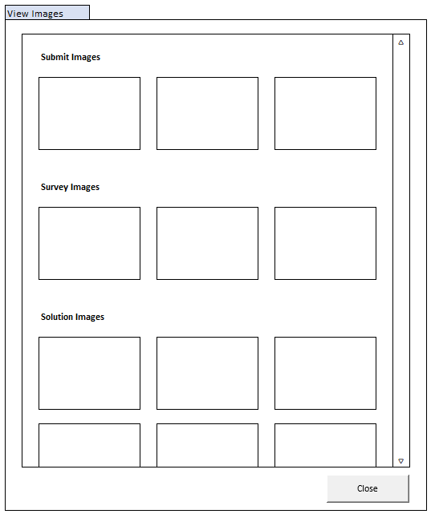

##### BUTTON DEFINITION

|  |  |  |
| --- | --- | --- |
| **Button Name** | **Action** | **Enabled** |
| Close | Close this popup |  |

##### INPUT PARAMETER

|  |  |
| --- | --- |
| **Parameter Name** | **Description** |
| PARAM_CARE_TICKET_NO | FORM_DATA.CCARE_TICKET_NO from DETAIL TAB |
| PARAM_PROPERTY_ID | FORM_DATA.CPROPERTY_ID from DETAIL TAB |

##### ROLES

|  |  |
| --- | --- |
|  | **Test** |
| * User yg punya akses ke program |  |

##### INITIAL PROCESS

|  |  |
| --- | --- |
|  | **Test** |
| * Load data from Input Parameter * Set Popup’s Width: 800px * Set Popup’s Height: 900px * **Load CARE Survey Images**   Jalankan RSP_HD_GET_CARE_IMAGES dengan parameter, simpan hasil ke VAR_SURVEY_IMAGES   * + VAR_COMPANY_ID   + PARAM_PROPERTY_ID   + PARAM_CARE_TICKET_NO   + ‘01’   + VAR_LANG_ID * **Load CARE Solution Images**   Jalankan RSP_HD_GET_CARE_IMAGES dengan parameter, simpan hasil ke VAR_SOLUTION_IMAGES   * + VAR_COMPANY_ID   + PARAM_PROPERTY_ID   + PARAM_CARE_TICKET_NO   + ‘02’   + VAR_LANG_ID * **Load CARE Submit Images**   Jalankan RSP_HD_GET_CARE_IMAGES dengan parameter, simpan hasil ke VAR_SUBMIT_IMAGES   * + VAR_COMPANY_ID   + PARAM_PROPERTY_ID   + PARAM_CARE_TICKET_NO   + ‘04’   + VAR_LANG_ID |  |

##### DISPLAY PROCESS

###### FIELD DEFINITION

|  |  |  |  |
| --- | --- | --- | --- |
| **Name** | **Field** | **Type** | **Validation** |
| **Scrollable Area** |  |  | Width: 750px  Height: 800px |
| **Submit Images** | For each image in VAR_SUBMIT_IMAGES’S, create Image Box | **Data:** VAR_SUBMIT_IMAGES | Hidden on,  VAR_SURVEY_IMAGES’s length < 1 |
| Image Box | CIMAGE_STORAGE_ID | ImageBox | MaxWidth: 250px  MaxHeight: 200px  On Clicked,  Go to 🡪 ZOOM IMAGE PROCESS |
| **Survey Images** | For each image in VAR_SURVEY_IMAGES’S, create Image Box | **Data:** VAR_SURVEY_IMAGES | Hidden on,  VAR_SURVEY_IMAGES’s length < 1 |
| Image Box | CIMAGE_STORAGE_ID | ImageBox | MaxWidth: 250px  MaxHeight: 200px  On Clicked,  Go to 🡪 ZOOM IMAGE PROCESS |
| **Solution Images** | For each image in VAR_SOLUTION_IMAGES’S, create Image Box | **Data**: VAR_SOLUTION_IMAGES | Hidden on,  VAR_SOLUTION_IMAGES’s length < 1 |
| Image Box | CIMAGE_STORAGE_ID | ImageBox | Max Image Per Row = 3  MaxWidth: 250px  MaxHeight: 200px  On Clicked,  Go to 🡪 ZOOM IMAGE PROCESS |

#### VIEW CHECKLIST PROCESS (POPUP)

##### USER INTERFACE

###### INITIAL VERSION

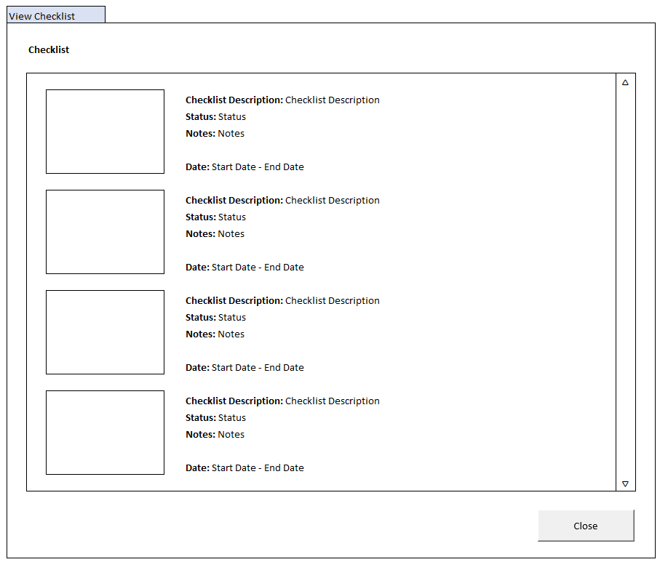

##### BUTTON DEFINITION

|  |  |  |
| --- | --- | --- |
| **Button Name** | **Action** | **Enabled** |
| Close | Close this popup |  |

##### INPUT PARAMETER

|  |  |
| --- | --- |
| **Parameter Name** | **Description** |
| PARAM_CARE_TICKET_NO | FORM_DATA.CCARE_TICKET_NO from DETAIL TAB |
| PARAM_PROPERTY_ID | FORM_DATA.CPROPERTY_ID from DETAIL TAB |

##### ROLES

|  |  |
| --- | --- |
|  | **Test** |
| * User yg punya akses ke program |  |

##### INITIAL PROCESS

|  |  |
| --- | --- |
|  | **Test** |
| * Load data from Input Parameter * Set Popup’s Width: 1200px * Set Popup’s Height: 900px * **Load CARE Checklist**   Jalankan RSP_HD_GET_CARE_CHECKLIST dengan parameter, simpan hasil ke VAR_CHECKLIST_LIST   * + VAR_COMPANY_ID   + PARAM_PROPERTY_ID   + PARAM_CARE_TICKET_NO   + VAR_LANG_ID |  |

##### DISPLAY PROCESS

###### FIELD DEFINITION

|  |  |  |  |
| --- | --- | --- | --- |
| **Name** | **Field** | **Type** | **Validation** |
| **Checklist** |  |  |  |
| **Scrollable Area** |  |  | Width: 1150px  Height: 800px |
| Checklist Card | For each image in VAR_SURVEY_IMAGES’S, create Checklist Card | **Data:** VAR_CHECKLIST_LIST | Hidden on,  VAR_CHECKLIST_LIST’s length < 1 |
| Checklist Image | CIMAGE_STORAGE_ID | ImageBox | MaxWidth: 250px  MaxHeight: 200px  On Clicked,  Go to 🡪 ZOOM IMAGE PROCESS |
| Checklist Description | CCHECKLIST_DESCRIPTION | Label |  |
| Status | LSTATUS | Label | IF LSTATUS = 1, then “OK”  Else, “Not OK” |
| Notes | CNOTES | Label |  |
| Date | DSTART_DATE, DEND_DATE  Convert to user’s long date time format | Label | Set Display:  CSTART_DATE – CEND_DATE |

#### ZOOM IMAGE PROCESS (POPUP)

##### USER INTERFACE

###### INITIAL VERSION



##### BUTTON DEFINITION

|  |  |  |
| --- | --- | --- |
| **Button Name** | **Action** | **Enabled** |
| Close | Close this popup |  |

##### INPUT PARAMETER

|  |  |
| --- | --- |
| **Parameter Name** | **Description** |
| PARAM_IMAGE | IMAGE_DATA from Image Box from DETAIL TAB |

##### ROLES

|  |  |
| --- | --- |
|  | **Test** |
| * User yg punya akses ke program |  |

##### INITIAL PROCESS

|  |  |
| --- | --- |
|  | **Test** |
| * Load data from Input Parameter |  |

##### DISPLAY PROCESS

###### FIELD DEFINITION

|  |  |  |  |
| --- | --- | --- | --- |
| **Name** | **Field** | **Type** | **Validation** |
| Image Viewer | PARAM_IMAGE | ImageBox | MaxWidth: 1000px  MaxHeight: 800px |

#### CANCEL PROCESS

##### ACTION

|  |
| --- |
|  |
| * Close this DETAIL TAB |
|  |

#### COMPLETE PROCESS

##### VALIDATION

|  |  |  |
| --- | --- | --- |
| **Field** | **Condition** | **Validation Message** |
| Actual Start Date | LACTUAL_EDITABLE = TRUE &  DACTUAL_START_DATE is EMPTY | Please fill Actual Start Date! |
| Actual End Date | LACTUAL_EDITABLE = TRUE &  DACTUAL_END_DATE is EMPTY | Please fill Actual End Date! |
| Actual Start Date & Actual End Date | LACTUAL_EDITABLE = TRUE &  DACTUAL_END_DATE < DACTUAL_START_DATE | Actual End Date cannot be before Actual Start Date! |
| Solution | LSOLUTION_EDITABLE = TRUE &  CSOLUTION | Please fill Solution! |
| Reviewer Notes | IF any VAR_SUPERVISOR_LIST. CREVIEW_NOTES is EMPTY | Please fill Reviewer Notes for every Supervisor! |

##### ACTION

|  |
| --- |
|  |
| * **Validate** (See VALIDATION table)   IF Success, jalankan **Complete CARE**  IF Failed, stay on Detail Tab |
| * **Complete CARE**   Jalankan RSP_HD_COMPLETE_CARE dengan parameter  @CCOMPANY_ID = VAR_COMPANY_ID  @CPROPERTY_ID = FORM_DATA.CPROPERTY_ID  @CCARE_TICKET_NO = FORM_DATA.CCARE_TICKET_NO  @DACTUAL_START_DATE = FORM_DATA.DACTUAL_START_DATE  @DACTUAL_END_DATE = FORM_DATA.DACTUAL_END_DATE  @CSOLUTION = FORM_DATA.CSOLUTION  @CUSER_ID = VAR_USER_ID |
| * Close this DETAIL TAB * Refresh **CARE Grid** di TAB CARE PROCESS |

### CONFIRM/CLOSE CARE PROCESS (DETAIL TAB)

#### USER INTERFACE

##### INITIAL VERSION

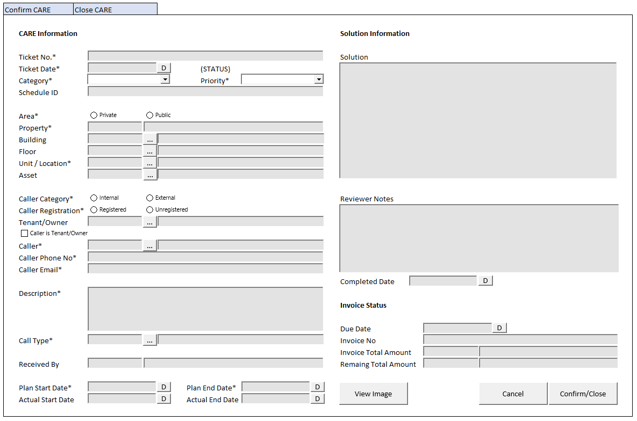

#### BUTTON DEFINITION

|  |  |  |
| --- | --- | --- |
| **Button Name** | **Action** | **Enabled** |
| View Images | Jalankan VIEW IMAGES PROCESS | * FORM_DATA.LVIEW_IMAGES = TRUE * HIDDEN on   FORM_DATA.CCARE_CATEGORY = ‘01’ |
| Cancel | Jalankan CANCEL PROCESS |  |
| Confirm | Jalankan CONFIRM PROCESS | * HIDDEN on   FORM_DATA.CSTATUS <> ‘06’ |
| Close | Jalankan CLOSE PROCESS | * HIDDEN on   FORM_DATA.CSTATUS <> ‘07’ |

#### INPUT PARAMETER

|  |  |
| --- | --- |
| **Parameter Name** | **Description** |
| PARAM_SELECTED_PROPERTY | VAR_SELECTED_PROPERTY from TAB CARE PROCESS |
| PARAM_SELECTED_CARE | VAR_SELECTED_CARE from TAB CARE PROCESS |

#### ROLES

|  |  |
| --- | --- |
|  | **Test** |
| * User yg punya akses ke program |  |

#### INITIAL PROCESS

|  |  |
| --- | --- |
|  | **Test** |
| * Load data from Input Parameter * **Load CARE Detail**   Jalankan RSP_HD_GET_CARE_DETAIL dengan parameter, simpan hasil ke FORM_DATA   * + VAR_COMPANY_ID   + VAR_SELECTED_PROPERTY.CPROPERTY_ID   + PARAM_SELECTED_CARE.CCARE_TICKET_NO   + VAR_LANG_ID |  |

#### DISPLAY PROCESS

##### FIELD DEFINITION

|  |  |  |  |
| --- | --- | --- | --- |
| **Name** | **Field** | **Type** | **Validation** |
| **Display Form** |  | **Data**: FORM_DATA |  |
| **CARE Information** |  |  |  |
| Ticket No. | CCARE_TICKET_NO | Textbox, Disabled, Required |  |
| Ticket Date | DCARE_TICKET_DATE | DateTimePicker, Disabled, Required |  |
| (STATUS) | CSTATUS, CSUBSTATUS  Set Display:  IF CSTATUS = ‘04’, then  ~~CSTATUS_DESCRIPTION~~ ~~(CSUBSTATUS_DESCRIPTION)~~  CSUBSTATUS_DESCRIPTION **[CR01]**  Else  CSTATUS_DESCRIPTION | Label, **BOLD** |  |
| Category | CCARE_CATEGORY | Combobox, Disabled, Required  Isi combobox dengan **VAR_CARE_CATEGORY**  Set ValueField = CCODE  Set TextField = CNAME  Simpan hasil ke CCARE_CATEGORY |  |
| Priority | CPRIORITY | Combobox, Disabled, Required  Isi combobox dengan **VAR_PRIORITY**  Set ValueField = CCODE  Set TextField = CNAME  Simpan hasil ke CPRIORITY |  |
| Schedule ID | CSCHEDULE_ID | Textbox, Disabled | Hidden on,  CCARE_CATEGORY <> ‘01’ |
| Area | CAREA | Radiobutton, Disabled, Required  Isi radiobutton dengan **VAR_AREA**  Set ValueField = CCODE  Set TextField = CNAME  Simpan hasil ke CAREA |  |
| Property | Set CPROPERTY_ID = PARAM_SELECTED_PROPERTY. CPROPERTY_ID | Textbox, Disabled, Required |  |
|  | Set CPROPERTY_NAME = PARAM_SELECTED_PROPERTY. CPROPERTY_NAME | Textbox, Disabled |  |
| Building | CBUILDING_ID | Textbox, Disabled |  |
|  |  | Lookup, Disabled |  |
|  | CBUILDING_NAME | Textbox, Disabled |  |
| Floor | CFLOOR_ID | Textbox, Disabled |  |
|  |  | Lookup, Disabled |  |
|  | CFLOOR_NAME | Textbox, Disabled |  |
| Unit/Location | CUNIT_LOCATION_ID | Textbox, Disabled, Required |  |
|  |  | Lookup, Disabled |  |
|  | CUNIT_LOCATION_NAME | Textbox, Disabled |  |
| Asset | CASSET_ID | Textbox, Disabled |  |
|  |  | Lookup, Disabled |  |
|  | CASSET_NAME | Textbox, Disabled |  |
| Caller Category | CCALLER_CATEGORY | Radiobutton, Disabled, Required  Isi radiobutton dengan **VAR_CALLER_CATEGORY**  Set ValueField = CCODE  Set TextField = CNAME  Simpan hasil ke CCALLER_CATEGORY |  |
| Caller Registration | CCALLER_REGISTRATION | Radiobutton, Disabled, Required  Isi radiobutton dengan **VAR_CALLER_REGISTRAION**  Set ValueField = CCODE  Set TextField = CNAME  Simpan hasil ke CCALLER_REGISTRATION |  |
| Tenant/Owner | CTENANT_OWNER_ID | Textbox, Disabled |  |
|  |  | Lookup, Disabled |  |
|  | CTENANT_OWNER_NAME | Textbox, Disabled |  |
|  | CTENANT_OWNER_PHONE | Hidden |  |
|  | CTENANT_OWNER_EMAIL | Hidden |  |
| Caller is Tenant/Owner | LCALLER_IS_TENANT | Checkbox, Disabled, Required |  |
| Caller | CCALLER_ID | Textbox, Disabled, Required |  |
|  |  | Lookup, Disabled |  |
|  | CCALLER_NAME | Textbox, Disabled, Required |  |
| Caller Phone No | CCALLER_PHONE | Textbox, Disabled, Required |  |
| Caller Email | CCALLER_EMAIL | Textbox, Disabled, Required |  |
| Description | CCARE_DESCRIPTION | Textarea, Disabled, Required |  |
| Call Type | CCALL_TYPE_ID | Textbox, Disabled, Required |  |
|  |  | Lookup, Disabled |  |
|  | CCALL_TYPE_NAME | Textbox, Disabled |  |
| Call Type Days | CCALL_TYPE_DAYS | Hidden |  |
| Call Type Hours | CCALL_TYPE_HOURS | Hidden |  |
| Call Type Minutes | CCALL_TYPE_MINUTES | Hidden |  |
| Submitted By | CRECEIVED_BY | Textbox, Disabled |  |
|  | DRECEIVED_DATE | DateTimePicker, Disabled |  |
| Plan Start Date | DPLAN_START_DATE | DateTimePicker, Disabled, Required |  |
| Plan End Date | DPLAN_END_DATE | DateTimePicker, Disabled |  |
| Actual Start Date | DACTUAL_START_DATE | DateTimePicker, Disabled |  |
| Actual End Date | DACTUAL_END_DATE | DateTimePicker, Disabled |  |
| **Solution Information** |  |  |  |
| Solution | CSOLUTION | Textarea, Disabled |  |
| Reviewer Notes | CREVIEW_NOTES | Textarea, Disabled |  |
| Completed Date | DCOMPLETED_DATE | DateTimePicker, Disabled |  |
| **Invoice Status** |  |  |  |
| Due Date | CINVOICE_DUE_DATE  Convert to DINVOICE_DUE_DATE from “YYYYMMDD” format | DatePicker, Disabled |  |
| Invoice No | CINVOICE_REF_NO | Textbox, Disabled |  |
| Invoice Total Amount | CCURRENCY_CODE | Textbox, Disabled |  |
|  | NINVOICE_TOTAL_AMOUNT | NumericTextbox, Disabled | Decimal Places = 2  Thousand Separator = TRUE |
| Remaining Total Amount | CCURRENCY_CODE | Textbox, Disabled |  |
|  | NINVOICE_REMAINING_TOTAL_AMOUNT | NumericTextbox, Disabled | Decimal Places = 2  Thousand Separator = TRUE |

#### VIEW IMAGES PROCESS (POPUP)

##### USER INTERFACE

###### INITIAL VERSION

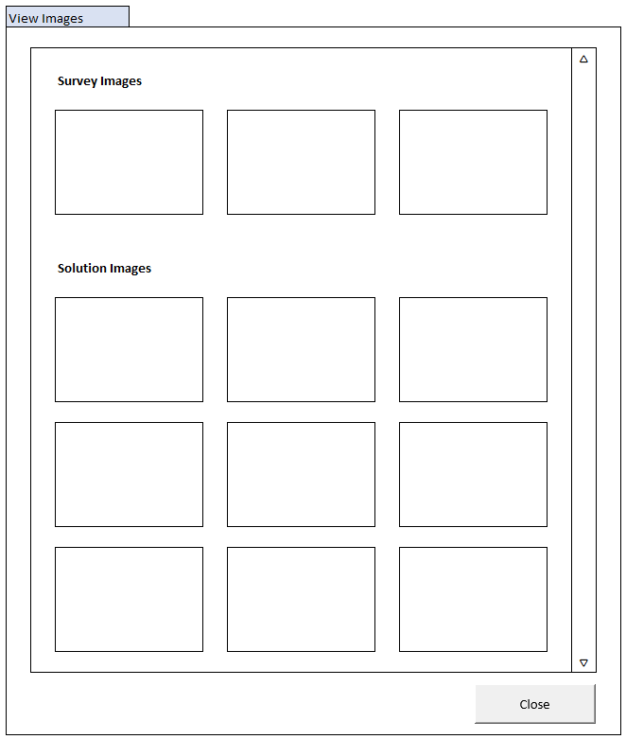

##### BUTTON DEFINITION

|  |  |  |
| --- | --- | --- |
| **Button Name** | **Action** | **Enabled** |
| Close | Close this popup |  |

##### INPUT PARAMETER

|  |  |
| --- | --- |
| **Parameter Name** | **Description** |
| PARAM_CARE_TICKET_NO | FORM_DATA.CCARE_TICKET_NO from DETAIL TAB |
| PARAM_PROPERTY_ID | FORM_DATA.CPROPERTY_ID from DETAIL TAB |

##### ROLES

|  |  |
| --- | --- |
|  | **Test** |
| * User yg punya akses ke program |  |

##### INITIAL PROCESS

|  |  |
| --- | --- |
|  | **Test** |
| * Load data from Input Parameter * Set Popup’s Width: 800px * Set Popup’s Height: 900px * **Load CARE Survey Images**   Jalankan RSP_HD_GET_CARE_IMAGES dengan parameter, simpan hasil ke VAR_SURVEY_IMAGES   * + VAR_COMPANY_ID   + PARAM_PROPERTY_ID   + PARAM_CARE_TICKET_NO   + ‘01’   + VAR_LANG_ID * **Load CARE Solution Images**   Jalankan RSP_HD_GET_CARE_IMAGES dengan parameter, simpan hasil ke VAR_SOLUTION_IMAGES   * + VAR_COMPANY_ID   + PARAM_PROPERTY_ID   + PARAM_CARE_TICKET_NO   + ‘02’   + VAR_LANG_ID |  |

##### DISPLAY PROCESS

###### FIELD DEFINITION

|  |  |  |  |
| --- | --- | --- | --- |
| **Name** | **Field** | **Type** | **Validation** |
| **Scrollable Area** |  |  | Width: 750px  Height: 800px |
| **Survey Images** | For each image in VAR_SURVEY_IMAGES’S, create Image Box | **Data:** VAR_SURVEY_IMAGES | Hidden on,  VAR_SURVEY_IMAGES’s length < 1 |
| Image Box | CIMAGE_STORAGE_ID | ImageBox | MaxWidth: 250px  MaxHeight: 200px  On Clicked,  Go to 🡪 ZOOM IMAGE PROCESS |
| **Solution Images** | For each image in VAR_SOLUTION_IMAGES’S, create Image Box | **Data**: VAR_SOLUTION_IMAGES | Hidden on,  VAR_SOLUTION_IMAGES’s length < 1 |
| Image Box | CIMAGE_STORAGE_ID | ImageBox | Max Image Per Row = 3  MaxWidth: 250px  MaxHeight: 200px  On Clicked,  Go to 🡪 ZOOM IMAGE PROCESS |

#### CANCEL PROCESS

##### ACTION

|  |
| --- |
|  |
| * Close this DETAIL TAB |
|  |

#### CONFIRM PROCESS

##### VALIDATION

|  |  |  |
| --- | --- | --- |
| **Field** | **Condition** | **Validation Message** |
|  |  |  |

##### ACTION

|  |
| --- |
|  |
| * **Validate** (See VALIDATION table)   IF Success, jalankan **Confirm CARE**  IF Failed, stay on Detail Tab |
| * **Confirm CARE**   Jalankan RSP_HD_CARE_PROCESS dengan parameter  @CCOMPANY_ID = VAR_COMPANY_ID  @CPROPERTY_ID = FORM_DATA.CPROPERTY_ID  @CCARE_TICKET_NO = FORM_DATA.CCARE_TICKET_NO  @CACTION = ‘03’  @CUSER_ID = VAR_USER_ID |
| * Close this DETAIL TAB * Refresh **CARE Grid** di TAB CARE PROCESS |

#### CLOSE PROCESS

##### VALIDATION

|  |  |  |
| --- | --- | --- |
| **Field** | **Condition** | **Validation Message** |
|  |  |  |

##### ACTION

|  |
| --- |
|  |
| * **Validate** (See VALIDATION table)   IF Success, jalankan **Close CARE**  IF Failed, stay on Detail Tab |
| * **Close CARE**   Jalankan RSP_HD_CARE_PROCESS dengan parameter  @CCOMPANY_ID = VAR_COMPANY_ID  @CPROPERTY_ID = FORM_DATA.CPROPERTY_ID  @CCARE_TICKET_NO = FORM_DATA.CCARE_TICKET_NO  @CACTION = ‘04’  @CUSER_ID = VAR_USER_ID |
| * Close this DETAIL TAB * Refresh **CARE Grid** di TAB CARE PROCESS |

## ALL LOOKUP PROCESS

### BUILDING LOOKUP PROCESS

#### ON LOST FOCUS

##### PARAMETER

|  |  |
| --- | --- |
| **Parameter Name** | **Description** |
| CPROPERTY_ID | FORM_DATA.CPROPERTY_ID from DETAIL TAB |
| CSEARCH_TEXT | FORM_DATA.CBUILDING_ID from DETAIL TAB |

##### ACTION

|  |
| --- |
|  |
| * Run **GSL02200 – Building Lookup** dengan parameter:   + CPROPERTY_ID   + CSEARCH_TEXT * Set **Display Form**   CBUILDING_ID = LOOKUP_RETURN_VALUE.CBUILDING_ID  CBUILDING_NAME = LOOKUP_RETURN_VALUE.CBUILDING_NAME |
|  |

#### BEFORE OPEN LOOKUP

##### PARAMETER

|  |  |
| --- | --- |
| **Parameter Name** | **Description** |
| CPROPERTY_ID | FORM_DATA.CPROPERTY_ID from DETAIL TAB |
| CSEARCH_TEXT | ‘’ |

##### ACTION

|  |
| --- |
|  |
| * Run **GSL02200 – Building Lookup** dengan parameter:   + CPROPERTY_ID   + CSEARCH_TEXT |
|  |

#### AFTER OPEN LOOKUP

##### CANCEL PROCESS

###### ACTION

|  |
| --- |
|  |
| * Close this lookup |
|  |

##### LOOKUP SELECT DATA PROCESS

###### ACTION

|  |
| --- |
|  |
| * Close this lookup * Set **Display Form**   CBUILDING_ID = LOOKUP_RETURN_VALUE.CBUILDING_ID  CBUILDING_NAME = LOOKUP_RETURN_VALUE.CBUILDING_NAME |
|  |

### FLOOR LOOKUP PROCESS

#### ON LOST FOCUS

##### PARAMETER

|  |  |
| --- | --- |
| **Parameter Name** | **Description** |
| CPROPERTY_ID | FORM_DATA.CPROPERTY_ID from DETAIL TAB |
| CBUILDING_ID | FORM_DATA.CBUILDING_ID from DETAIL TAB |
| CSEARCH_TEXT | FORM_DATA.CFLOOR_ID from DETAIL TAB |

##### ACTION

|  |
| --- |
|  |
| * Run **GSL02400 – Floor Lookup** dengan parameter:   + CPROPERTY_ID   + CBUILDING_ID   + CSEARCH_TEXT * Set **Display Form**   CFLOOR_ID = LOOKUP_RETURN_VALUE.CFLOOR_ID  CFLOOR_NAME = LOOKUP_RETURN_VALUE.CFLOOR_NAME |
|  |

#### BEFORE OPEN LOOKUP

##### PARAMETER

|  |  |
| --- | --- |
| **Parameter Name** | **Description** |
| CPROPERTY_ID | FORM_DATA.CPROPERTY_ID from DETAIL TAB |
| CBUILDING_ID | FORM_DATA.CBUILDING_ID from DETAIL TAB |
| CSEARCH_TEXT | ‘’ |

##### ACTION

|  |
| --- |
|  |
| * Run **GSL02400 – Floor Lookup** dengan parameter:   + CPROPERTY_ID   + CBUILDING_ID   + CSEARCH_TEXT |
|  |

#### AFTER OPEN LOOKUP

##### CANCEL PROCESS

###### ACTION

|  |
| --- |
|  |
| * Close this lookup |
|  |

##### LOOKUP SELECT DATA PROCESS

###### ACTION

|  |
| --- |
|  |
| * Close this lookup * Set **Display Form**   CFLOOR_ID = LOOKUP_RETURN_VALUE.CFLOOR_ID  CFLOOR_NAME = LOOKUP_RETURN_VALUE.CFLOOR_NAME |
|  |

### UNIT LOOKUP PROCESS

#### ON LOST FOCUS

##### PARAMETER

|  |  |
| --- | --- |
| **Parameter Name** | **Description** |
| CPROPERTY_ID | FORM_DATA.CPROPERTY_ID from DETAIL TAB |
| CBUILDING_ID | FORM_DATA.CBUILDING_ID from DETAIL TAB |
| CFLOOR_ID | FORM_DATA.CFLOOR_ID from DETAIL TAB |
| CSEARCH_TEXT | FORM_DATA.CUNIT_LOCATION_ID from DETAIL TAB |

##### ACTION

|  |
| --- |
|  |
| * Run **GSL02300 – Unit Lookup** dengan parameter:   + CPROPERTY_ID   + CBUILDING_ID   + CFLOOR_ID   + CSEARCH_TEXT * Set **Display Form**   CUNIT_LOCATION_ID = LOOKUP_RETURN_VALUE.CUNIT_LOCATION_ID  CUNIT_LOCATION_NAME = LOOKUP_RETURN_VALUE.CUNIT_LOCATION_NAME |
|  |

#### BEFORE OPEN LOOKUP

##### PARAMETER

|  |  |
| --- | --- |
| **Parameter Name** | **Description** |
| CPROPERTY_ID | FORM_DATA.CPROPERTY_ID from DETAIL TAB |
| CBUILDING_ID | FORM_DATA.CBUILDING_ID from DETAIL TAB |
| CFLOOR_ID | FORM_DATA.CFLOOR_ID from DETAIL TAB |
| CSEARCH_TEXT | ‘’ |

##### ACTION

|  |
| --- |
|  |
| * Run **GSL02300 – Unit Lookup** dengan parameter:   + CPROPERTY_ID   + CBUILDING_ID   + CFLOOR_ID   + CSEARCH_TEXT |
|  |

#### AFTER OPEN LOOKUP

##### CANCEL PROCESS

###### ACTION

|  |
| --- |
|  |
| * Close this lookup |
|  |

##### LOOKUP SELECT DATA PROCESS

###### ACTION

|  |
| --- |
|  |
| * Close this lookup * Set **Display Form**   CUNIT_LOCATION_ID = LOOKUP_RETURN_VALUE.CUNIT_LOCATION_ID  CUNIT_LOCATION_NAME = LOOKUP_RETURN_VALUE.CUNIT_LOCATION_NAME |
|  |

### LOCATION LOOKUP PROCESS

#### ON LOST FOCUS

##### PARAMETER

|  |  |
| --- | --- |
| **Parameter Name** | **Description** |
| CCOMPANY_ID | VAR_COMPANY_ID |
| CPROPERTY_ID | FORM_DATA.CPROPERTY_ID from DETAIL TAB |
| CUSER_ID | VAR_USER_ID |
| CSEARCH_TEXT | FORM_DATE.CUNIT_LOCATION_ID from DETAIL TAB |

##### ACTION

|  |
| --- |
|  |
| * Run **HDL00300 – Public Location Lookup** dengan parameter:   + CCOMPANY_ID   + CPROPERTY_ID   + CUSER_ID   + CSEARCH_TEXT * Set **Display Form**   CUNIT_LOCATION_ID = LOOKUP_RETURN_VALUE.CUNIT_LOCATION_ID  CUNIT_LOCATION_NAME = LOOKUP_RETURN_VALUE.CUNIT_LOCATION_NAME  CBUILDING_ID = LOOKUP_RETURN_VALUE.CBUILDING_ID  CFLOOR_ID = LOOKUP_RETURN_VALUE.CFLOOR_ID |
|  |

#### BEFORE OPEN LOOKUP

##### PARAMETER

|  |  |
| --- | --- |
| **Parameter Name** | **Description** |
| CCOMPANY_ID | VAR_COMPANY_ID |
| CPROPERTY_ID | FORM_DATA.CPROPERTY_ID from DETAIL TAB |
| CUSER_ID | VAR_USER_ID |
| CSEARCH_TEXT | ‘’ |

##### ACTION

|  |
| --- |
|  |
| * Run **HDL00300 – Public Location Lookup** dengan parameter:   + CCOMPANY_ID   + CPROPERTY_ID   + CUSER_ID   + CSEARCH_TEXT |
|  |

#### AFTER OPEN LOOKUP

##### CANCEL PROCESS

###### ACTION

|  |
| --- |
|  |
| * Close this lookup |
|  |

##### LOOKUP SELECT DATA PROCESS

###### ACTION

|  |
| --- |
|  |
| * Close this lookup * Set **Display Form**   CUNIT_LOCATION_ID = LOOKUP_RETURN_VALUE.CUNIT_LOCATION_ID  CUNIT_LOCATION_NAME = LOOKUP_RETURN_VALUE.CUNIT_LOCATION_NAME  CBUILDING_ID = LOOKUP_RETURN_VALUE.CBUILDING_ID  CFLOOR_ID = LOOKUP_RETURN_VALUE.CFLOOR_ID |
|  |

### ASSET LOOKUP PROCESS

#### ON LOST FOCUS

##### PARAMETER

|  |  |
| --- | --- |
| **Parameter Name** | **Description** |
| CCOMPANY_ID | VAR_COMPANY_ID |
| CPROPERTY_ID | FORM_DATA.CPROPERTY_ID from DETAIL TAB |
| CBUILDING_ID | FORM_DATA.CBUILDING_ID from DETAIL TAB |
| CFLOOR_ID | FORM_DATA.CFLOOR_ID from DETAIL TAB |
| CUNIT_ID | IF CAREA = ‘01’, then FORM_DATA.CUNIT_LOCATION_ID from DETAIL TAB, else ‘’ |
| CLOCATION_ID | IF CAREA = ‘02’, then FORM_DATA.CUNIT_LOCATION_ID from DETAIL TAB, else ‘’ |
| CUSER_ID | VAR_USER_ID |
| CSEARCH_TEXT | FORM_DATA.CASSET_ID from DETAIL TAB |

##### ACTION

|  |
| --- |
|  |
| * Run **HDL00400 – Asset Lookup** dengan parameter:   + CCOMPANY_ID   + CPROPERTY_ID   + CBUILDING_ID   + CFLOOR_ID   + CUNIT_ID   + CUSER_ID   + CSEARCH_TEXT * Set **Display Form**   CASSET_ID = LOOKUP_RETURN_VALUE.CASSET_ID  CASSET_NAME = LOOKUP_RETURN_VALUE.CASSET_NAME  CBUILDING_ID = LOOKUP_RETURN_VALUE.CBUILDING_ID  CFLOOR_ID = LOOKUP_RETURN_VALUE.CFLOOR_ID  CUNIT_LOCATION_ID = LOOKUP_RETURN_VALUE.CUNIT_LOCATION_ID |
|  |

#### BEFORE OPEN LOOKUP

##### PARAMETER

|  |  |
| --- | --- |
| **Parameter Name** | **Description** |
| CCOMPANY_ID | VAR_COMPANY_ID |
| CPROPERTY_ID | FORM_DATA.CPROPERTY_ID from DETAIL TAB |
| CBUILDING_ID | FORM_DATA.CBUILDING_ID from DETAIL TAB |
| CFLOOR_ID | FORM_DATA.CFLOOR_ID from DETAIL TAB |
| CUNIT_ID | FORM_DATA.CUNIT_LOCATION_ID from DETAIL TAB |
| CUSER_ID | VAR_USER_ID |
| CSEARCH_TEXT | ‘’ |

##### ACTION

|  |
| --- |
|  |
| * Run **HDL00400 – Asset Lookup** dengan parameter:   + CCOMPANY_ID   + CPROPERTY_ID   + CBUILDING_ID   + CFLOOR_ID   + CUNIT_ID   + CUSER_ID   + CSEARCH_TEXT |
|  |

#### AFTER OPEN LOOKUP

##### CANCEL PROCESS

###### ACTION

|  |
| --- |
|  |
| * Close this lookup |
|  |

##### LOOKUP SELECT DATA PROCESS

###### ACTION

|  |
| --- |
|  |
| * Close this lookup * Set **Display Form**   CASSET_ID = LOOKUP_RETURN_VALUE.CASSET_ID  CASSET_NAME = LOOKUP_RETURN_VALUE.CASSET_NAME  CBUILDING_ID = LOOKUP_RETURN_VALUE.CBUILDING_ID  CFLOOR_ID = LOOKUP_RETURN_VALUE.CFLOOR_ID  CUNIT_LOCATION_ID = LOOKUP_RETURN_VALUE.CUNIT_LOCATION_ID |
|  |

### UNIT TENANT LOOKUP PROCESS

#### ON LOST FOCUS

##### PARAMETER

|  |  |
| --- | --- |
| **Parameter Name** | **Description** |
| CCOMPANY_ID | VAR_COMPANY_ID |
| CPROPERTY_ID | FORM_DATA.CPROPERTY_ID from DETAIL TAB |
| CBUILDING_ID | FORM_DATA.CBUILDING_ID from DETAIL TAB |
| CFLOOR_ID | FORM_DATA.CFLOOR_ID from DETAIL TAB |
| CUNIT_ID | FORM_DATA.CUNIT_LOCATION_ID from DETAIL TAB |
| CUSER_ID | VAR_USER_ID |
| CLANG_ID | VAR_LANG_ID |
| CSEARCH_TEXT | FORM_DATA.CTENANT_OWNER_ID from DETAIL TAB |

##### ACTION

|  |
| --- |
|  |
| * Run **PML01800 – Unit Tenant Lookup** dengan parameter:   + CCOMPANY_ID   + CPROPERTY_ID   + CBUILDING_ID   + CFLOOR_ID   + CUNIT_ID   + CUSER_ID   + CLANG_ID   + CSEARCH_TEXT * Set **Display Form**   IF called from CTENANT_OWNER_ID’s field, set  CTENANT_OWNER_ID = LOOKUP_RETURN_VALUE.CTENANT_ID  CTENANT_OWNER_NAME = LOOKUP_RETURN_VALUE.CTENANT_NAME  CTENANT_OWNER_PHONE = LOOKUP_RETURN_VALUE.CPHONE1  CTENANT_OWNER_EMAIL = LOOKUP_RETURN_VALUE.CEMAIL  CTENANT_OR_OWNER = LOOKUP_RETURN_VALUE.CTENANT_OR_OWNER  IF called from CCALLER_ID’s field, set  CCALLER_ID = LOOKUP_RETURN_VALUE.CTENANT_ID  CCALLER_NAME = LOOKUP_RETURN_VALUE.CTENANT_NAME  CCALLER_PHONE = LOOKUP_RETURN_VALUE.CPHONE1  CCALLER_EMAIL = LOOKUP_RETURN_VALUE.CEMAIL |
|  |

#### BEFORE OPEN LOOKUP

##### PARAMETER

|  |  |
| --- | --- |
| **Parameter Name** | **Description** |
| CCOMPANY_ID | VAR_COMPANY_ID |
| CPROPERTY_ID | FORM_DATA.CPROPERTY_ID from DETAIL TAB |
| CBUILDING_ID | FORM_DATA.CBUILDING_ID from DETAIL TAB |
| CFLOOR_ID | FORM_DATA.CFLOOR_ID from DETAIL TAB |
| CUNIT_ID | FORM_DATA.CUNIT_LOCATION_ID from DETAIL TAB |
| CUSER_ID | VAR_USER_ID |
| CLANG_ID | VAR_LANG_ID |
| CSEARCH_TEXT | ‘’ |

##### ACTION

|  |
| --- |
|  |
| * Run **PML01800 – Unit Tenant Lookup** dengan parameter:   + CCOMPANY_ID   + CPROPERTY_ID   + CBUILDING_ID   + CFLOOR_ID   + CUNIT_ID   + CUSER_ID   + CLANG_ID   + CSEARCH_TEXT |
|  |

#### AFTER OPEN LOOKUP

##### CANCEL PROCESS

###### ACTION

|  |
| --- |
|  |
| * Close this lookup |
|  |

##### LOOKUP SELECT DATA PROCESS

###### ACTION

|  |
| --- |
|  |
| * Close this lookup * Set **Display Form**   IF called from CTENANT_OWNER_ID’s field, set  CTENANT_OWNER_ID = LOOKUP_RETURN_VALUE.CTENANT_ID  CTENANT_OWNER_NAME = LOOKUP_RETURN_VALUE.CTENANT_NAME  CTENANT_OWNER_PHONE = LOOKUP_RETURN_VALUE.CPHONE1  CTENANT_OWNER_EMAIL = LOOKUP_RETURN_VALUE.CEMAIL  CTENANT_OR_OWNER = LOOKUP_RETURN_VALUE.CTENANT_OR_OWNER  IF called from CCALLER_ID’s field, set  CCALLER_ID = LOOKUP_RETURN_VALUE.CTENANT_ID  CCALLER_NAME = LOOKUP_RETURN_VALUE.CTENANT_NAME  CCALLER_PHONE = LOOKUP_RETURN_VALUE.CPHONE1  CCALLER_EMAIL = LOOKUP_RETURN_VALUE.CEMAIL |
|  |

### TENANT LOOKUP PROCESS

#### ON LOST FOCUS

##### PARAMETER

|  |  |
| --- | --- |
| **Parameter Name** | **Description** |
| CCOMPANY_ID | VAR_COMPANY_ID |
| CPROPERTY_ID | FORM_DATA.CPROPERTY_ID from DETAIL TAB |
| CCUSTOMER_TYPE | ‘01’ |
| CUSER_ID | VAR_USER_ID |
| CSEARCH_TEXT | FORM_DATA.CTENANT_OWNER_ID from DETAIL TAB |

##### ACTION

|  |
| --- |
|  |
| * Run **PML00600 – Tenant Lookup** dengan parameter:   + CCOMPANY_ID   + CPROPERTY_ID   + CCUSTOMER_TYPE   + CUSER_ID   + CSEARCH_TEXT * Set **Display Form**   IF called from CTENANT_OWNER_ID’s field, set  CTENANT_OWNER_ID = LOOKUP_RETURN_VALUE.CTENANT_ID  CTENANT_OWNER_NAME = LOOKUP_RETURN_VALUE.CTENANT_NAME  CTENANT_OWNER_PHONE = LOOKUP_RETURN_VALUE.CPHONE1  CTENANT_OWNER_EMAIL = LOOKUP_RETURN_VALUE.CEMAIL  CTENANT_OR_OWNER = “”  IF called from CCALLER_ID’s field, set  CCALLER_ID = LOOKUP_RETURN_VALUE.CTENANT_ID  CCALLER_NAME = LOOKUP_RETURN_VALUE.CTENANT_NAME  CCALLER_PHONE = LOOKUP_RETURN_VALUE.CPHONE1  CCALLER_EMAIL = LOOKUP_RETURN_VALUE.CEMAIL |
|  |

#### BEFORE OPEN LOOKUP

##### PARAMETER

|  |  |
| --- | --- |
| **Parameter Name** | **Description** |
| CCOMPANY_ID | VAR_COMPANY_ID |
| CPROPERTY_ID | FORM_DATA.CPROPERTY_ID from DETAIL TAB |
| CCUSTOMER_TYPE | ‘01’ |
| CUSER_ID | VAR_USER_ID |
| CSEARCH_TEXT | ‘’ |

##### ACTION

|  |
| --- |
|  |
| * Run **PML00600 – Tenant Lookup** dengan parameter:   + CCOMPANY_ID   + CPROPERTY_ID   + CCUSTOMER_TYPE   + CUSER_ID   + CSEARCH_TEXT |
|  |

#### AFTER OPEN LOOKUP

##### CANCEL PROCESS

###### ACTION

|  |
| --- |
|  |
| * Close this lookup |
|  |

##### LOOKUP SELECT DATA PROCESS

###### ACTION

|  |
| --- |
|  |
| * Close this lookup * Set **Display Form**   IF called from CTENANT_OWNER_ID’s field, set  CTENANT_OWNER_ID = LOOKUP_RETURN_VALUE.CTENANT_ID  CTENANT_OWNER_NAME = LOOKUP_RETURN_VALUE.CTENANT_NAME  CTENANT_OWNER_PHONE = LOOKUP_RETURN_VALUE.CPHONE1  CTENANT_OWNER_EMAIL = LOOKUP_RETURN_VALUE.CEMAIL  CTENANT_OR_OWNER = “”  IF called from CCALLER_ID’s field, set  CCALLER_ID = LOOKUP_RETURN_VALUE.CTENANT_ID  CCALLER_NAME = LOOKUP_RETURN_VALUE.CTENANT_NAME  CCALLER_PHONE = LOOKUP_RETURN_VALUE.CPHONE1  CCALLER_EMAIL = LOOKUP_RETURN_VALUE.CEMAIL |
|  |

### CALL TYPE LOOKUP PROCESS

#### ON LOST FOCUS

##### PARAMETER

|  |  |
| --- | --- |
| **Parameter Name** | **Description** |
| CPROPERTY_ID | FORM_DATA.CPROPERTY_ID from DETAIL TAB |
| CSEARCH_TEXT | FORM_DATA.CCALL_TYPE_ID from DETAIL TAB |

##### ACTION

|  |
| --- |
|  |
| * Run **PML01600 – SLA Call Type Lookup** dengan parameter:   + CPROPERTY_ID   + CSEARCH_TEXT * Set **Display Form**   CCALL_TYPE_ID = LOOKUP_RETURN_VALUE.CCALL_TYPE_ID  CCALL_TYPE_NAME = LOOKUP_RETURN_VALUE.CCALL_TYPE_NAME  CCALL_TYPE_DAYS = LOOKUP_RETURN_VALUE.CCALL_TYPE_DAYS  CCALL_TYPE_HOURS = LOOKUP_RETURN_VALUE.CCALL_TYPE_HOURS  CCALL_TYPE_MINUTES = LOOKUP_RETURN_VALUE.CCALL_TYPE_MINUTES |
|  |

#### BEFORE OPEN LOOKUP

##### PARAMETER

|  |  |
| --- | --- |
| **Parameter Name** | **Description** |
| CPROPERTY_ID | FORM_DATA.CPROPERTY_ID from DETAIL TAB |
| CSEARCH_TEXT | ‘’ |

##### ACTION

|  |
| --- |
|  |
| * Run **PML01600 – SLA Call Type Lookup** dengan parameter:   + CPROPERTY_ID   + CSEARCH_TEXT |
|  |

#### AFTER OPEN LOOKUP

##### CANCEL PROCESS

###### ACTION

|  |
| --- |
|  |
| * Close this lookup |
|  |

##### LOOKUP SELECT DATA PROCESS

###### ACTION

|  |
| --- |
|  |
| * Close this lookup * Set **Display Form**   CCALL_TYPE_ID = LOOKUP_RETURN_VALUE.CCALL_TYPE_ID  CCALL_TYPE_NAME = LOOKUP_RETURN_VALUE.CCALL_TYPE_NAME  CCALL_TYPE_DAYS = LOOKUP_RETURN_VALUE.CCALL_TYPE_DAYS  CCALL_TYPE_HOURS = LOOKUP_RETURN_VALUE.CCALL_TYPE_HOURS  CCALL_TYPE_MINUTES = LOOKUP_RETURN_VALUE.CCALL_TYPE_MINUTES |
|  |

### SUPERVISOR LOOKUP PROCESS

#### ON LOST FOCUS

##### PARAMETER

|  |  |
| --- | --- |
| **Parameter Name** | **Description** |
| CCOMPANY_ID | VAR_COMPANY_ID |
| CPROPERTY_ID | FORM_DATA.CPROPERTY_ID from DETAIL TAB |
| CUSER_ID | VAR_USER_ID |
| CSEARCH_TEXT | VAR_SELECTED_SUPERVISOR.CSUPERVISOR_ID from DETAIL TAB |

##### ACTION

|  |
| --- |
|  |
| * Run **PML00300 – Supervisor Lookup** dengan parameter:   + CCOMPANY_ID   + CPROPERTY_ID   + CUSER_ID   + CSEARCH_TEXT * Set **Supervisor Grid’s** selected row   CSUPERVISOR_ID = LOOKUP_RETURN_VALUE.CSUPERVISOR  CSUPERVISOR_NAME = LOOKUP_RETURN_VALUE.CSUPERVISOR_NAME  CSUPERVISOR_DEPT_CODE = LOOKUP_RETURN_VALUE.CDEPT_CODE  CSUPERVISOR_DEPT_NAME = LOOKUP_RETURN_VALUE.CDEPT_NAME |
|  |

#### BEFORE OPEN LOOKUP

##### PARAMETER

|  |  |
| --- | --- |
| **Parameter Name** | **Description** |
| CCOMPANY_ID | VAR_COMPANY_ID |
| CPROPERTY_ID | FORM_DATA.CPROPERTY_ID from DETAIL TAB |
| CUSER_ID | VAR_USER_ID |
| CSEARCH_TEXT | ‘’ |

##### ACTION

|  |
| --- |
|  |
| * Run **PML00300 – Supervisor Lookup** dengan parameter:   + CCOMPANY_ID   + CPROPERTY_ID   + CUSER_ID   + CSEARCH_TEXT |
|  |

#### AFTER OPEN LOOKUP

##### CANCEL PROCESS

###### ACTION

|  |
| --- |
|  |
| * Close this lookup |
|  |

##### LOOKUP SELECT DATA PROCESS

###### ACTION

|  |
| --- |
|  |
| * Close this lookup * Set **Supervisor Grid’s** selected row   CSUPERVISOR_ID = LOOKUP_RETURN_VALUE.CSUPERVISOR  CSUPERVISOR_NAME = LOOKUP_RETURN_VALUE.CSUPERVISOR_NAME  CSUPERVISOR_DEPT_CODE = LOOKUP_RETURN_VALUE.CDEPT_CODE  CSUPERVISOR_DEPT_NAME = LOOKUP_RETURN_VALUE.CDEPT_NAME |
|  |

### STAFF LOOKUP PROCESS

#### ON LOST FOCUS

##### PARAMETER

|  |  |
| --- | --- |
| **Parameter Name** | **Description** |
| CCOMPANY_ID | VAR_COMPANY_ID |
| CPROPERTY_ID | FORM_DATA.CPROPERTY_ID from DETAIL TAB |
| CSUPERVISOR_ID | Join all VAR_SUPERVISOR_LIST.CSUPERVISOR_ID with ‘,’ where CSUPERVISOR_ROLE <> ‘A’ from DETAIL TAB  Ex, “STF01, STF02” |
| LSUPERVISOR | 1 |
| CDEPT_CODE | Join all VAR_SUPERVISOR_LIST.CSUPERVISOR_DEPT_CODE with ‘,’ where CSUPERVISOR_ROLE <> ‘A’ from DETAIL TAB |
| CACTIVE_INACTIVE | 1 |
| CSTAFF_TYPE | ‘00’ |
| CUSER_ID | VAR_USER_ID |
| CLANG_ID | VAR_LANG_ID |
| CSEARCH_TEXT | VAR_SELECTED_STAFF.CSTAFF_ID from DETAIL TAB |

##### ACTION

|  |
| --- |
|  |
| * Run **PML01900 – Staff Lookup** dengan parameter:   + CCOMPANY_ID   + CPROPERTY_ID   + CSUPERVISOR_ID   + LSUPERVISOR   + CDEPT_CODE   + CACTIVE_INACTIVE   + CSTAFF_TYPE   + CUSER_ID   + CLANG_ID   + CSEARCH_TEXT * Set **Staff Grid’s** selected row   CSTAFF_ID = LOOKUP_RETURN_VALUE.CSTAFF_ID  CSTAFF_NAME = LOOKUP_RETURN_VALUE.CSTAFF_NAME  CSTAFF_DEPT_CODE = LOOKUP_RETURN_VALUE.CDEPT_CODE  CSTAFF_DEPT_NAME = LOOKUP_RETURN_VALUE.CDEPT_NAME  CSTAFF_SUPERVISOR_ID = LOOKUP_RETURN_VALUE.CSUPERVISOR  IF called from CCALLER_ID’s field, ALSO set  CTENANT_OR_OWNER = “” |
|  |

#### BEFORE OPEN LOOKUP

##### PARAMETER

|  |  |
| --- | --- |
| **Parameter Name** | **Description** |
| CCOMPANY_ID | VAR_COMPANY_ID |
| CPROPERTY_ID | FORM_DATA.CPROPERTY_ID from DETAIL TAB |
| CSUPERVISOR_ID | Join all VAR_SUPERVISOR_LIST.CSUPERVISOR_ID with ‘,’ where CSUPERVISOR_ROLE <> ‘A’ from DETAIL TAB  Ex, “STF01, STF02” |
| LSUPERVISOR | 1 |
| CDEPT_CODE | Join all VAR_SUPERVISOR_LIST.CSUPERVISOR_DEPT_CODE with ‘,’ where CSUPERVISOR_ROLE <> ‘A’ from DETAIL TAB |
| CACTIVE_INACTIVE | 1 |
| CSTAFF_TYPE | ‘00’ |
| CUSER_ID | VAR_USER_ID |
| CLANG_ID | VAR_LANG_ID |
| CSEARCH_TEXT | ‘’ |

##### ACTION

|  |
| --- |
|  |
| * Run **PML01900 – Staff Lookup** dengan parameter:   + CCOMPANY_ID   + CPROPERTY_ID   + CSUPERVISOR_ID   + LSUPERVISOR   + CDEPT_CODE   + CACTIVE_INACTIVE   + CSTAFF_TYPE   + CUSER_ID   + CLANG_ID   + CSEARCH_TEXT |
|  |

#### AFTER OPEN LOOKUP

##### CANCEL PROCESS

###### ACTION

|  |
| --- |
|  |
| * Close this lookup |
|  |

##### LOOKUP SELECT DATA PROCESS

###### ACTION

|  |
| --- |
|  |
| * Close this lookup * Set **Staff Grid’s** selected row   CSTAFF_ID = LOOKUP_RETURN_VALUE.CSTAFF_ID  CSTAFF_NAME = LOOKUP_RETURN_VALUE.CSTAFF_NAME  CSTAFF_DEPT_CODE = LOOKUP_RETURN_VALUE.CDEPT_CODE  CSTAFF_DEPT_NAME = LOOKUP_RETURN_VALUE.CDEPT_NAME  CSTAFF_SUPERVISOR_ID = LOOKUP_RETURN_VALUE.CSUPERVISOR  IF called from CCALLER_ID’s field, ALSO set  CTENANT_OR_OWNER = “” |
|  |

### ADMIN LOOKUP PROCESS

#### ON LOST FOCUS

##### PARAMETER

|  |  |
| --- | --- |
| **Parameter Name** | **Description** |
| CCOMPANY_ID | VAR_COMPANY_ID |
| CPROPERTY_ID | FORM_DATA.CPROPERTY_ID from DETAIL TAB |
| CSUPERVISOR_ID | ‘’ |
| LSUPERVISOR | 1 |
| CDEPT_CODE | ‘’ |
| CACTIVE_INACTIVE | 1 |
| CSTAFF_TYPE | ‘AD’ |
| CUSER_ID | VAR_USER_ID |
| CLANG_ID | VAR_LANG_ID |
| CSEARCH_TEXT | VAR_SELECTED_SUPERVISOR.CSUPERVISOR_ID from DETAIL TAB |

##### ACTION

|  |
| --- |
|  |
| * Run **PML01900 – Staff Lookup** dengan parameter:   + CCOMPANY_ID   + CPROPERTY_ID   + CSUPERVISOR_ID   + LSUPERVISOR   + CDEPT_CODE   + CACTIVE_INACTIVE   + CSTAFF_TYPE   + CUSER_ID   + CLANG_ID   + CSEARCH_TEXT * Set **Supervisor Grid’s** selected row   CSUPERVISOR_ID = LOOKUP_RETURN_VALUE.CSUPERVISOR  CSUPERVISOR_NAME = LOOKUP_RETURN_VALUE.CSUPERVISOR_NAME  CSUPERVISOR_DEPT_CODE = LOOKUP_RETURN_VALUE.CDEPT_CODE  CSUPERVISOR_DEPT_NAME = LOOKUP_RETURN_VALUE.CDEPT_NAME |
|  |

#### BEFORE OPEN LOOKUP

##### PARAMETER

|  |  |
| --- | --- |
| **Parameter Name** | **Description** |
| CCOMPANY_ID | VAR_COMPANY_ID |
| CPROPERTY_ID | FORM_DATA.CPROPERTY_ID from DETAIL TAB |
| CSUPERVISOR_ID | ‘’ |
| LSUPERVISOR | 1 |
| CDEPT_CODE | ‘’ |
| CACTIVE_INACTIVE | 1 |
| CSTAFF_TYPE | ‘AD’ |
| CUSER_ID | VAR_USER_ID |
| CLANG_ID | VAR_LANG_ID |
| CSEARCH_TEXT | ‘’ |

##### ACTION

|  |
| --- |
|  |
| * Run **PML01900 – Staff Lookup** dengan parameter:   + CCOMPANY_ID   + CPROPERTY_ID   + CSUPERVISOR_ID   + LSUPERVISOR   + CDEPT_CODE   + CACTIVE_INACTIVE   + CSTAFF_TYPE   + CUSER_ID   + CLANG_ID   + CSEARCH_TEXT |
|  |

#### AFTER OPEN LOOKUP

##### CANCEL PROCESS

###### ACTION

|  |
| --- |
|  |
| * Close this lookup |
|  |

##### LOOKUP SELECT DATA PROCESS

###### ACTION

|  |
| --- |
|  |
| * Close this lookup * Set **Supervisor Grid’s** selected row   CSUPERVISOR_ID = LOOKUP_RETURN_VALUE.CSUPERVISOR  CSUPERVISOR_NAME = LOOKUP_RETURN_VALUE.CSUPERVISOR_NAME  CSUPERVISOR_DEPT_CODE = LOOKUP_RETURN_VALUE.CDEPT_CODE  CSUPERVISOR_DEPT_NAME = LOOKUP_RETURN_VALUE.CDEPT_NAME |
|  |

### PRICELIST ITEM LOOKUP PROCESS

#### BEFORE OPEN LOOKUP

##### PARAMETER

|  |  |
| --- | --- |
| **Parameter Name** | **Description** |
| CCOMPANY_ID | VAR_COMPANY_ID |
| CPROPERTY_ID | FORM_DATA.CPROPERTY_ID from DETAIL TAB |
| CSTATUS | ‘1’ |
| CTAXABLE | ‘0’ |
| CUSER_ID | VAR_USER_ID |
| CLOOKUP_DATE | FORM_DATA.DCARE_TICKET_DATE |
| CSLA_CALL_TYPE_ID | IF LSEARCH_WITH_SLA = TRUE, then  FORM_DATA.CCALL_TYPE_ID  Else, ‘’ |
| CSEARCH_TEXT | ‘’ |

##### ACTION

|  |
| --- |
|  |
| * Run **HDL00200 – Pricelist Item Lookup** dengan parameter:   + CCOMPANY_ID   + CPROPERTY_ID   + CSTATUS   + CTAXABLE   + CUSER_ID   + CLOOKUP_DATE   + CSLA_CALL_TYPE_ID   + CSEARCH_TEXT |
|  |

#### AFTER OPEN LOOKUP

##### CANCEL PROCESS

###### ACTION

|  |
| --- |
|  |
| * Close this lookup |
|  |

##### LOOKUP SELECT DATA PROCESS

###### ACTION

|  |
| --- |
|  |
| * Close this lookup * Set **Charges Grid’s** selected row   CPRICELIST_ID = LOOKUP_RETURN_VALUE.CPRICELIST_ID  CVALID_ID = LOOKUP_RETURN_VALUE.CVALID_ID  CPRICELIST_NAME = LOOKUP_RETURN_VALUE.CPRICELIST_NAME  CDEPT_CODE = LOOKUP_RETURN_VALUE.CDEPT_CODE  CCHARGES_ID = LOOKUP_RETURN_VALUE.CCHARGES_ID  CCURRENCY_CODE = LOOKUP_RETURN_VALUE.CCURRENCY_CODE  IPRICE = LOOKUP_RETURN_VALUE.IPRICE  CUNIT = LOOKUP_RETURN_VALUE.CUNIT |
|  |

# CR LIST

|  |  |  |
| --- | --- | --- |
| **CR** | **Description** | **Notes** |
| CR01  NS, 22 Jan 2024 | * Menambahkan Building di GRID * Menukar Kolom Caller dan Category * Menambahkan Condition untuk button CREATE NEW CARE * Mengubah tampilan (CSTATUS) di dalam popup |  |